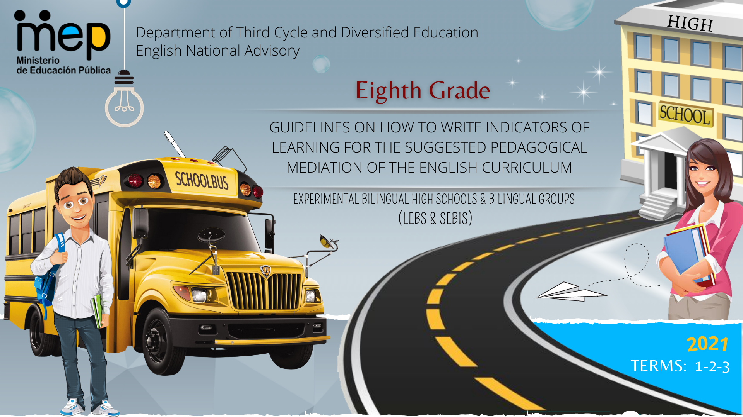

**Autoridades**

**Giselle Cruz Maduro**

Ministro de Educación Pública

**Melania Brenes Monge**

Viceministra Académica de Educación

**María Alexandra Ulate Espinoza**

Directora de la Dirección de Desarrollo Curricular

**Rigoberto Corrales Zúñiga**

Jefe del Departamento de Tercer Ciclo y Educación Diversificada

**Comisión redactora**

**Mag. Marianella Granados Sirias,**

Asesora Nacional de Inglés, Departamento de Tercer Ciclo y Educación Diversificada

**Mag. Alfredo Ortega Cordero**,

Asesor Nacional de Inglés, Departamento de Tercer Ciclo y Educación Diversificada

**Mag. Andrea Cruz Badilla**

Asesora Nacional de Inglés, Departamento de Tercer Ciclo y Educación Diversificada

**Sandra Araya Acuña**

Asesora Regional DRE Guápiles

**Max Arias**

Asesor Regional DRE Liberia

**Livia Gamboa Cordero**

Asesora Regional DRE San Carlos

**Ezequiel Rojas Gutiérrez**

Asesor Regional DRE San José Central

**Diana Sanchún Orozco**

Asesora Regional DRE Nicoya

**Melissa González Castro**

Asesora Regional DRE San José Norte

**Comisión validadora**

Ivannia Arias Zúñiga. Sección Bilingüe Español-Inglés Liceo de Sinaí

Félix Díaz Castañeda, Sección Bilingüe Español-Inglés Liceo de Nicoya

Karen Pereira Meneses, Liceo de Costa Rica

Ana Lucía Ramírez Rodríguez, Liceo de Costa Rica

David Valerio Sánchez, Liceo de Costa Rica

Juliana Sánchez Sánchez, Sección Bilingüe Español-Inglés Liceo San Rafael

Roberto Segnini Cabezas, Sección Bilingüe Español-Inglés Liceo de Colorado

Luis Diego Soto Delgado, Sección Bilingüe Español-Inglés Liceo de Higuito

**Diseño de portada**

**Noelia González Cascante**

Dirección Regional de Educación Guápiles

**Table of Contents**

1. Presentation …………………………………………………………………………………………………………………….….…5
2. Aims of the document ……………………………………………………………………………………………………….….……5
3. Important points to keep in mind when working with the indicators…………………………………………………………..…6
4. Tasks and their relationship with indicators of learning …………………………………………………………………………..7
5. Indicators of Learning ………...............................................................................................................................................9
6. 8th Grade Indicators of Learning …………………………………………………………………………………….……………11
7. Indicators of Learning Term 1………………………………………………………………………..………………………….....15
8. Indicators of Learning Term 2 ……………………….………………………………………………………………….…….......32
9. Indicators of Learning Term 3 ……………………………………………………………………………………………..………51
10. Sample Rubrics for Self-Study Guides ………………………………………………………….………………………...…...…68
11. Rubrics for Oral & Written Comprehension……………………………………………………………………….….…….…….69
12. Rubrics for and Oral & Written Production………………………………………………………………………………....…….74
13. Sample Rubrics and Performance Scale for Summative Assessment Instruments and the Assessment Promotion Strategy ………………………………………………………………………………………………………………………………75
14. References ……………………………………………………………………………………………………………..……………82

**Presentation**

**Dear teachers:**

These guidelines intend to provide English teachers of eighth grade with important information on how effectively write indicators and create assessment instruments for their Self-Study Guides (GTA) and the assessment promotion strategy or *estrategia de promoción* in Spanish. It includes sample rubrics and performance scales for summative and formative assessment in oral and written comprehension and oral and written production. All the indicators and instruments will help teachers to measure the goals and the three learnings (Learn to Know, Learn to Do, Learn to Be and Live in Community) set in the new English curriculum when designing tasks. As a result, learners can achieve the expected level of performance in the target language according to the CEFR. We believe that you know your students best and therefore we encourage you **to adapt and contextualize** what you find here so that it responds to the needs of your learners. Remember to visit the following link https://recursos.mep.go.cr/lebs_y_sebi/:

**Aims of this document:**

1. To give teachers a brief explanation on how to write indicators of learning for planning their Self-Study Guides (GTA in Spanish).
2. To recommend a list of suggested indicators of learning per unit and linguistic competence according to the CEFR levels for Eighth Grade.
3. To offer some sample rubrics for the Self-Study Guides and sample rubrics and Performance Scales for Summative Assessment and Formative Assessment Instruments.

Best,

English Secondary National Advisors

**Important points to keep in mind when working with the indicators.**

The CEFR defines communication as a social act, where learners are social agents, developing a range of general and specific communicative language competences, moving from learning about the language to learning to communicate in the language in active, spontaneous, and authentic language interaction. Most of the tasks to be accomplished have a meaningful communication objective, for example, solving a problem in a given scenario.

The CEFR defines competences as “the sum of knowledge, skills and characteristics that allow a person to perform actions in society.” (p.9). They are comprised of general and specific competences as shown in the following graphic organizer. General competences consist of knowledge, skills, and abilities to learn and existential competence that are not language-specific, but learners use them when performing all kinds of actions including language activities.

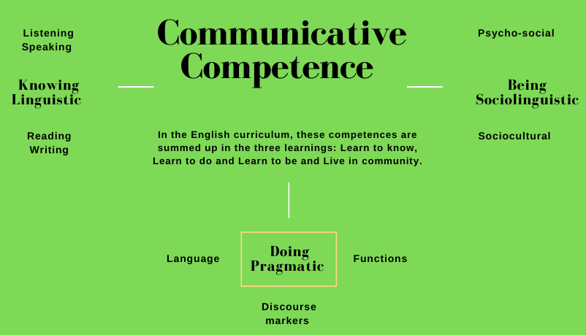

**Tasks and their relationship with indicators of learning**

When working with the Action–Oriented Approach (AOA), teachers need to design tasks that reflect the interests, abilities, and learning styles of their students for each linguistic competence or when integrating two of them. These tasks must have a variety of authentic texts and models of language (e.g., music, video clips, stories and news media). In regards to the indicators of learning, they are used to assess the tasks proposed during the pedagogical mediation process. Indicators of learning are strictly related to the task achievement, and they help to provide specific and timely descriptive feedback to students.

**What is a task?**

**What are the task features?**

|  |  |  |
| --- | --- | --- |
| Task features | | |
| Simple  (*Looking for special events in town*)  Complex  (*Planning a weekend with friends*) | Authentic situations  Individually and /or peers | When will this task happen in real life?  What is the task purpose?  What will be accomplished? |

**Task Sample**

**Simple Action- Oriented Task**

|  |  |  |
| --- | --- | --- |
| Authentic situation | | |
| **Assessment Strategy** | ***When would this task occur in real life?*** | ***What is the task purpose? What will be accomplished?*** |
| SI.1. asks and tells others his/her desires about shopping prices, size and where to get things. | Buying things at a convenience store. | Good morning! Can you help me? Where can I get a bottle of water? |

**Complex Action- Oriented Task**

|  |  |  |
| --- | --- | --- |
| Authentic situation | | |
| **Assessment Strategy** | ***When would this task occur in real life?*** | ***What is the task purpose? What will be accomplished?*** |
| SI.1. asks and tells others his/her desires about shopping prices, size and where to get things. | Buying things at a convenience store. | You are driving to Liberia city for a family vacation, and you stop for gas on the way. Go into a convenience store and buy supplies for the journey. Ask the sales assistant for help finding these items. Discuss price, quantity, payment options. |

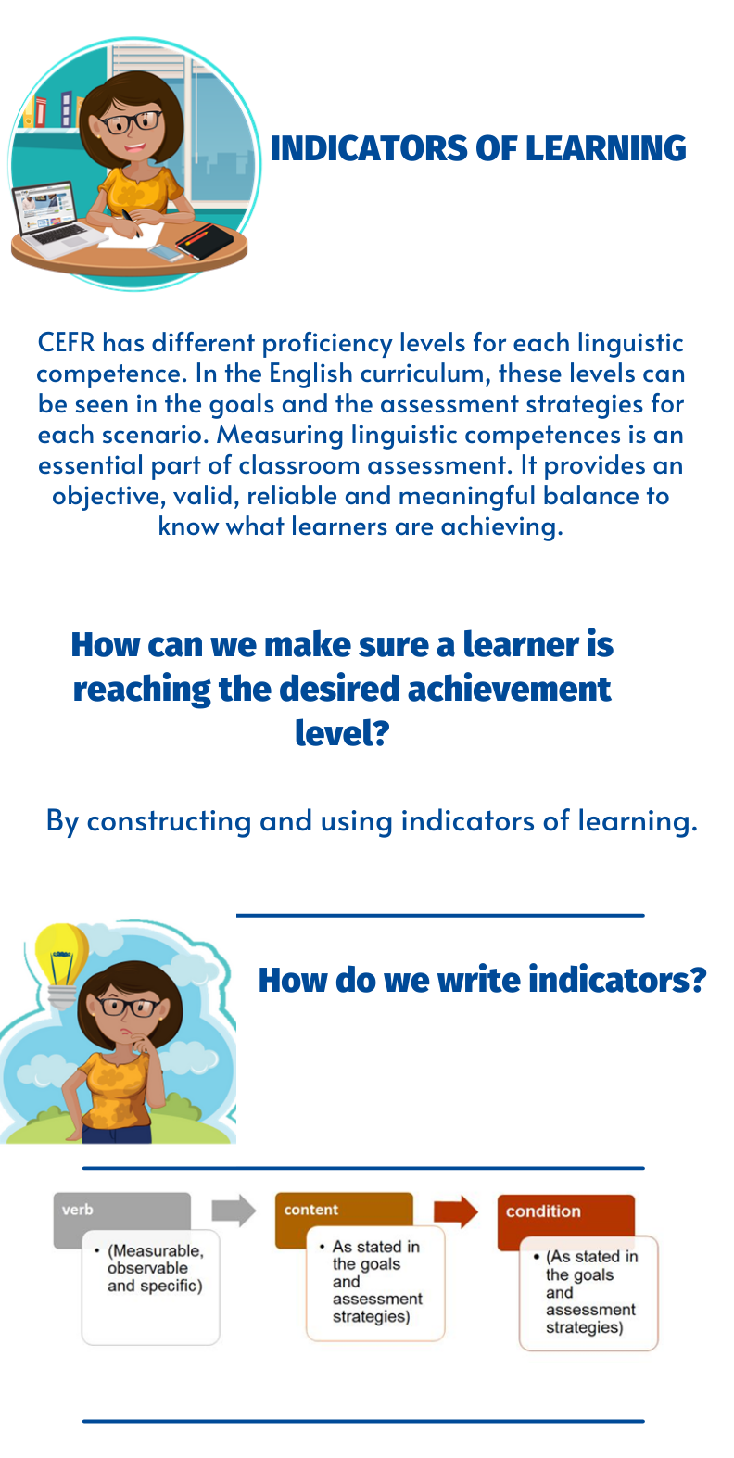

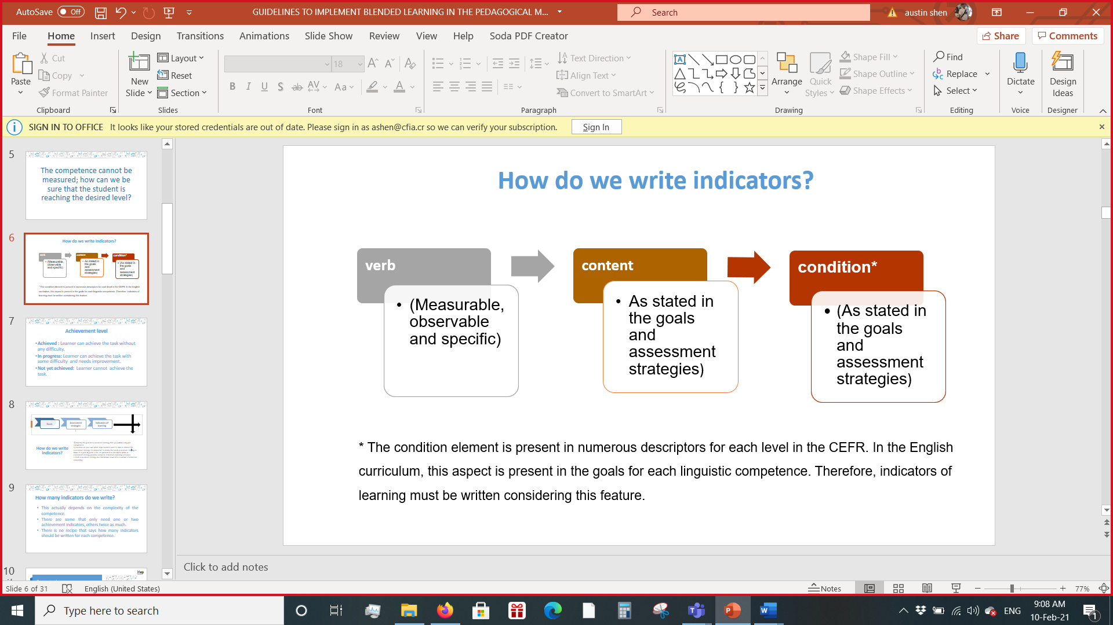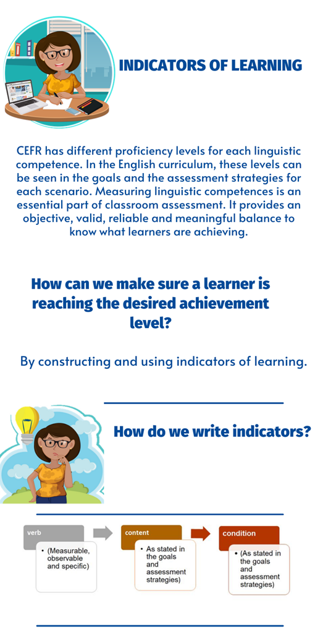

**\*** The condition element is present in numerous descriptors for each level in the CEFR. In the English curriculum, this aspect is present in the goals for each linguistic competence. Therefore, indicators of learning must be written considering this feature.

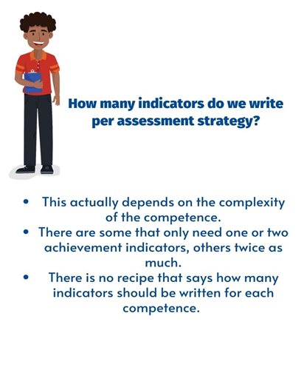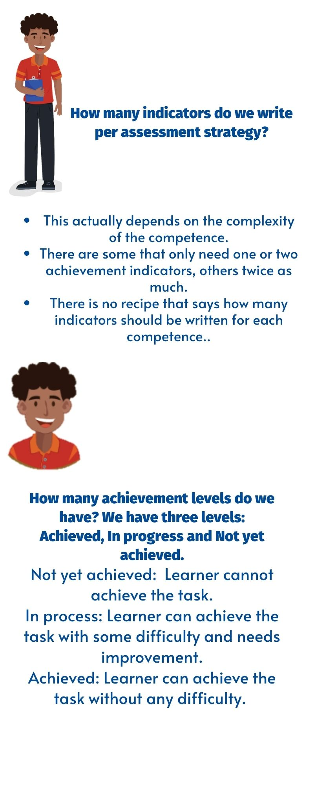

**8th Grade Indicators of Learning**

The 8th Grade curriculum and the teachers’ guide provide student-can-do descriptors called goals, accompanied by assessment strategies. These assessment strategies are evidence that a teacher can record to show that students are achieving the unit goals.

As classroom teachers, however, we do not simply assess students´ progress. We must guide students step by step through activities that enable them to reach their goals.

This document breaks each assessment strategy down into a number of indicators of learning. They are the steps that learners follow to achieve the goals. Indicators of learning have the following characteristics: measurable, observable and specific.

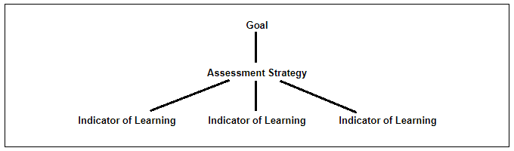

**How to use this document:**

1) Identify the goal and assessment strategy that you will be using. Remember, a goal is a can- do performance descriptor while an assessment strategy provides evidence of learner’s learning outcomes.

2) Consider the steps or indicators learners need to follow to achieve each assessment strategy. It is important to clarify that each assessment strategy is linked to a goal. See the example below:

|  |  |  |
| --- | --- | --- |
| **Goal** | **Assessment Strategy** | **Indicators of Learning** |
| **L.2.** Understand classroom language. | **L.2.** discriminates classroom language within oral utterances. | L2.1 Gets the gist of short conversations related to classroom language.  L2.2 Distinguish basic classroom expressions related to classroom language, from aural/oral stimulus. |

3) Find the unit and assessment strategy in this document and consult the list of indicators of learning to check your own work.

4) While teaching (Oral Comprehension, Written Comprehension, Oral Production, Written Production), guide students to accomplish each of the indicators of learning along the way to achieving the goals and assessment strategies. Remember that there should be a connection between the assessment strategies, indicators of learning, and pedagogical mediation for each competence.

5) Use indicators of learning throughout each unit to monitor students’ progress and make the corresponding mediation changes if necessary.

**Important considerations:**

1. Indicators of learning are organized by unit, then by assessment strategy.
2. It is important to take into account the corresponding level of difficulty of the assessment strategy when writing the indicators.
3. In some of the indicators proposed, teachers have to include the content of those indicators. To do that, they will complete the idea after the word “about”. For example: “Identifies facts in clearly drafted print materials about leisure activities”.
4. In most of the cases, the indicators of learning for each assessment strategy are arranged in a suggested order for students to perform them appropriately.
5. It is always necessary to use an indicator of learning, such as the one suggested in this document. As educators, teachers must use their own professional judgement to identify the steps their students most need to take to achieve the learning goals and that is reflected in the pedagogical mediation.
6. During the face- to- face and/or distance pedagogical mediation process, and therefore, at the end of each self-study guide, the teacher will use the indicators of learning to create instruments (rubrics and /or performance scales) to assess students’ achievement level.
7. The mediation activities in the self-study guides must be coherent with the indicators of learning to be included in the corresponding achievement rubric.
8. Remember that the Pre-teaching Stage **must not** consider indicators of learning. They are strictly related to the suggested mediation sequence for each linguistic competence. Not every step of the suggested mediation in the self-study guides/didactic planning must have indicators, only the ones that are necessary to achieve the corresponding assessment strategy and learning goal for each linguistic competence.
9. Most of the tasks suggested in the teacher‘s guide match the indicators of learning because they follow the mediation proposed for each competence. If you use the tasks proposed in the teacher’s guide for planning your self -study guides, make sure these tasks match with the steps proposed to mediate each competence and consequently the self-assessment section.
10. When revising the activities in the teacher´s guide or any other resource to plan your lessons, consider that you can follow the steps below as suggested by the Institute of Collaborative Learning:

* **S**elect the activity and leave it as it is
* **A**dapt it or change it somehow
* **R**eject it. Choose not to use it
* **S**upplement it. Enrich the activity with extra material to make it more appropriate.

Assessment Strategies & Indicators of Learning

| Level: 8th  Term: 1  CEFR Band: A2.2  Scenario: Having a say!  Oral Comprehension & Oral Production | | |
| --- | --- | --- |
| Assessment Strategies | Indicators of Learning | |
| L.1. identifies message enough to manage simple, routine exchanges. | L.1.1 | Gets main ideas from different audio texts. |
| L.1.2 | Identifies specific words or phrases in simple, routine exchanges. |
| L.1.3 | Identifies supporting details different audio texts. |
| L.2. identifies familiar topic of discussion. | L.2.1 | Identifies the topic from different audio texts. |
| L.2.1 | Identifies key words that are related to the topic. |
| L.3. recognizes phrases and expressions related to meeting concrete needs in everyday life. | L.3.1 | Gets the gist of an aural/oral stimulus. |
| L.3.2 | Gets meaning from specific phrases and expressions related to meeting concrete needs in everyday life. |
| L.3.3 | Identifies key words related to meeting concrete needs in everyday life. |
| L.3.4 | Recognizes specific phrases and expressions related to meeting concrete needs in everyday life in different audio texts. |
| L.4. recognizes clear, standard speech on familiar matters. | L.4.1 | Recognizes main points and ideas from clear, standard speech in audios, videos or read-alouds. |
| L.4.2 | Identifies key words, phrases and expressions in clear, standard speech on familiar matters. |
| L.4.3 | Recognizes specific information in clear, standard speech on familiar matters. |
| L.5. recognizes specifics and styles, incidents, lifestyles and healthy habits. | L.5.1 | Identifies the topic of an aural/oral stimulus. |
| L.5.2 | Gets main points from an oral stimulus related to incidents, lifestyles and healthy habits. |
| L.5.3 | Gets specific information from an oral stimulus related to specifics and styles, incidents, lifestyles and healthy habits. |
| L.5.4 | Relates familiar words and very basic phrases concerning specifics and styles, incidents, lifestyles and healthy habits. |
| L.5.5 | Recognizes specifics and styles, incidents, lifestyles and healthy habits. |
| L.6. compares and contrasts information. | L.6.1 | Gets main ideas from information given in audios, videos or read-alouds. |
| L.6.2 | Identifies similarities among details given in a specific context. |
| L.6.3 | Identifies differences among details given in a specific context. |
| L.6.4 | Compares information given in an aural/oral stimulus using graphic organizers. |
| L.6.5 | Contrasts information given in an aural/oral stimulus using graphic organizers. |
| L.7. interprets information from routine exchanges, short descriptions and narratives, anecdotes, the main points of view in short conversations in recorded passages about past experiences. | L.7.1 | Makes predictions by looking at pictures before listening to an audio. |
| L.7.2 | Gets main ideas from audios related to routine exchanges, short descriptions and narratives, anecdotes, the main points of view in short conversations in recorded passages about past experiences. |
| L.7.3 | Gets supporting ideas and specific details from audios related to routine exchanges, short descriptions and narratives, anecdotes, the main points of view in short conversations in recorded passages about past experiences. |
| L.7.4 | Identifies author’s argument from audios related to routine exchanges, short descriptions and narratives, anecdotes, the main points of view in short conversations in recorded passages about past experiences. |
| L.7.5 | Organizes information in a hierarchy (themes, main ideas, supporting ideas, and supporting details) using mapping, webbing or charting. |
| L.7.6 | Recalls what was said in audios related to routine exchanges, short descriptions and narratives, anecdotes, the main points of view in short conversations in recorded passages about past experiences. |
| L.7.7 | Interprets most of what was said in audios related routine exchanges, short descriptions and narratives, anecdotes, the main points of view in short conversations in recorded passages about past experiences using key ideas from the visualization- map. |
| L.8. makes inferences on situations or information based on audios/videos’ input. | L.8.1 | Gets the gist of audios/videos’ input. |
| L.8.2 | Identifies facts on situations or information based on audios/videos’ input. |
| L.8.3 | Deduces information from evidences found on situations or information based on audios/videos’ input. |
| SI.1. interacts in very short social exchanges. | SI.1.1 | Plans the language and content to interact in very short social exchanges. |
| SI.1.2 | Makes sentences using vocabulary, phrases or expressions to interact in very short social exchanges. |
| SI.1.3 | Expresses ideas to interact in very short social exchanges. |
| SI.1.4 | Replies to others using specific phrases and expressions to interact in very short social exchanges. |
| SI.2. interacts in routine tasks requiring simple and direct exchange of information about own life, dreams. | SI.2.1 | Plans the language and content to express ideas about own life and dreams. |
| SI.2.2 | Makes complete sentences about own life and dreams. |
| SI.2.3 | Expresses ideas using phrases in simple and direct  exchange of information about own life, dreams. |
| SI.2.4 | Replies to others using specific phrases and expressions in simple and direct exchange of information about own life, dreams. |
| SI.3. answers simple questions using individual words, expressions, or short sentences about childhood experiences and healthy habits. | SI.3.1 | Brainstorms words, expressions or phrases related to childhood experiences and healthy habits |
| SI.3.2 | Makes lists of expressions, phrases and single words used to answer simple questions about childhood experiences and healthy habits. |
| SI.3.3 | Answers simple questions using individual words, expressions, or short sentences about childhood experiences and healthy habits. |
| SI.4. asks for and give opinions, agrees and disagrees in a simple way about topics such as personal experiences, lifestyle and healthy habits. | SI.4.1 | Plans a set of expressions, phrases and single words used to asks for and give opinions, agree and disagree in a simple way about topics such as personal experiences, lifestyle and healthy habits |
| SI.4.2 | Makes sentences to ask for and give opinions, agree and disagree in a simple way about topics such as personal experiences, lifestyle and healthy habits. |
| SI.4.3 | Asks for opinions in topics such as personal experiences, lifestyle and healthy habits. |
| SI.4.4 | Gives opinions in topics such as personal experiences, lifestyle and healthy habits. |
| SI.4.5 | Uses phrases and expressions to agree in a simple way about topics such as personal experiences, lifestyle and healthy habits. |
| SI.4.6 | Uses phrases and expressions to disagree in a simple way about topics such as personal experiences, lifestyle and healthy habits. |
| SI.5. interacts in short telephone conversations with someone known in order to exchange e.g. news, tell about experiences, accidents, healthy habits, using learned phrases, questions, and responses. | SI.5.1 | Plans a set of learned phrases, questions, and responses used to interact in short telephone conversations with someone known in order to exchange e.g. news, tell about experiences, accidents, healthy habits. |
| SI.5.2 | Makes a lists of learned phrases, questions, and responses used to interact in short telephone conversations with someone known in order to exchange e.g. news, tell about experiences, accidents, healthy habits. |
| SI.5.3 | Asks questions over the phone to family or friends about news, experiences, accidents or healthy habits. |
| SI.5.4 | Answers questions over the phone to family or friends about news, experiences, accidents or healthy habits. |
| SI.6. provides basic information about past experiences, entertainment, lifestyle and healthy habits. | SI.6.1 | Selects the language and content to provide basic information about past experiences, entertainment, lifestyle and healthy habits. |
| SI.6.2 | Organizes information to narrate a past experience in graphic organizers, outlines or timelines. |
| SI.6.3 | Provides basic information about past experiences. |
| SI.6.4 | Provides basic information about entertainment. |
| SI.6.5 | Provides basic information about lifestyle and healthy habits. |
| SI.7. describes past events, dreams, hopes, ambitions and study experiences. | SI.7.1 | Selects the language, content and visuals to describe past events, dreams, hopes, ambitions and study experiences. |
| SI.7.2 | Make sentences to describe past events, dreams, hopes, ambitions and study experiences. |
| SI.7.3 | Describes past events. |
| SI.7.4 | Describes dreams, hopes and ambitions. |
| SI.7.5 | Describes study experiences. |
| SI.8 describes personality, emotions, and feelings and inquires as to how others feel. | SI.8.1 | Selects the language, content and visuals to describe personality, emotions, and feelings and to inquire as to how others feel. |
| SI.8.2 | Makes sentences to describe personality, emotions, and feelings and to inquire as to how others feel. |
| SI.8.3 | Describes his/her personality, emotions, and feelings. |
| SI.8.4 | Inquires others’ emotions and feelings. |
| SP.1. talks about familiar experiences and past events, places, using simple vocabulary and language constructions. | SP.1.1 | Selects simple vocabulary and language constructions to talk about familiar experiences and past events and places. |
| SP.1.2 | Makes complete sentences about familiar experiences and past events and places. |
| SP.1.3 | Talks about familiar experiences and past events using simple vocabulary and language constructions. |
| SP.1.4 | Talks about familiar places using simple vocabulary and language constructions. |
| SP.2. describes, in simple terms, sentences, his/her own past experiences, events, lifestyles and healthy habits using a series of phrases. | SP.2.1 | Brainstorms phrases or vocabulary used to describe his/her own past experiences, events, lifestyles and healthy habits. |
| SP.2.2 | Makes complete sentences with the appropriate linkers or connecting words to give a well-organized presentation about his/her own past experiences, events, lifestyles and healthy habits. |
| SP.2.3 | Describes his/her own past experiences and events using a series of phrases. |
| SP.2.4 | Describes his/her own lifestyles and healthy habits using a series of phrases. |
| SP.3. describes places, routines, plans, arrangements, past activities, last weekend or last holiday and experiences using simple vocabulary and language structures. | SP.3.1 | Selects simple vocabulary, language structures and visuals to give a presentation about places, routines, plans, arrangements, past activities, last weekend or last holiday and experiences. |
| SP.3.2 | Makes sentences with the information and the appropriate linkers or connecting words to give a well-organized presentation about places, routines, plans, arrangements, past activities, last weekend or last holiday and experiences. |
| SP.3.3 | Describes places using simple vocabulary and language structures. |
| SP.3.4 | Describes routines using simple vocabulary and language structures. |
| SP.3.5 | Describes plans and arrangements using simple vocabulary and language structures. |
| SP.3.6 | Describes past activities and experiences (last weekend or last holiday) using simple vocabulary and language structures. |
| SP.4. describes a past experience, special event, lifestyle and healthy habit, providing reasons for his/her opinion. | SP.4.1 | Selects the language, content and visuals to describe a past experience, special event, lifestyle and healthy habit, providing reasons for his/her opinion. |
| SP.4.2 | Makes sentences with the information and with the appropriate linkers or connecting words to give a well-organized presentation about a past experience, special event, lifestyle and healthy habit. |
| SP.4.3 | Describes a past experience providing reasons for his/her opinion. |
| SP.4.4 | Describes a special event providing reasons for his/her opinion. |
| SP.4.4 | Describes his/her lifestyle and healthy habit providing reasons for his/her opinion. |
| SP.5. summarizes simple stories that have been expressed in a simple sequence of past events. | SP.5.1 | Selects the appropriate information to summarize simple stories that have been expressed in a simple sequence of past events. |
| SP.5.2 | Organizes information and ideas to sequence events or actions in graphic organizers, timelines or outlines by placing them in some sort of order. |
| SP.5.3 | Summarizes simple stories that have been expressed in a simple sequence of past events using the information from the graphic organizers, timelines or outlines. |

Propuesta elaborada por: **Melissa González Castro, Asesora Regional de Inglés, DRE San José-Norte. Revisado Sandra Araya Acuña, Asesora Regional de Inglés, DRE Guápiles y** Marianella Granados Sirias, Alfredo Ortega Cordero, Andrea Cruz Badilla. Asesores Nacionales de Inglés. **Departamento de Tercer Ciclo y Educación Diversificada. Dirección de Desarrollo Curricular**

| Level: 8th  Term: 1  CEFR Band: A2.2  Scenario: Having a say!  Written Comprehension & Written Production | | | | |
| --- | --- | --- | --- | --- |
| Assessment Strategies | | | Indicators of Learning | |
| R.1. recognizes sequence details, main idea and the gist of short simple texts in print and/or electronic articles and ads in age-appropriate magazines on familiar topics. | | | R.1.1 | Gets the gist of short simple texts in print and/or electronic articles and ads in age-appropriate magazines on familiar topics. |
| R.1.2 | Recognizes the main idea of short simple texts on familiar topics in print and/or electronic articles and ads in age-appropriate magazines. |
| R.1.3 | Identifies key words that denote sequence. |
| R.1.4 | Recognizes sequence details in print and/or electronic articles and ads in age-appropriate magazines on familiar topics. |
| R.2. recognizes short, simple personal letters and texts about familiar topics. | | | R.2.1 | Gets the main idea of short, simple personal letters and texts about familiar topics. |
| R.2.2 | Identifies key words or phrases in short simple personal letters and texts about familiar topics. |
| R.2.3 | Recognizes specific information in short simple personal letters and texts about familiar topics. |
| R.3. recognizes previously encountered parts of words, prefixes, and suffixes. | | | R.3.1 | Gets the gist of texts that contain parts of words, prefixes and suffixes. |
| R.3.2 | Identifies parts of words. |
| R.3.3 | Identifies prefixes. |
| R.3.4 | Identifies suffixes. |
| R.3.4 | Recognizes previously encountered parts of words, prefixes, and suffixes. |
| R.4. makes predictions using prior knowledge, contextual and typographical /picture clues, titles, labels, headings, headlines, pictures, illustrations, visuals, key words and sequence of events. | | | R.4.1 | Gets the gist of messages to make predictions using prior knowledge, contextual and typographical/picture clues, titles, labels, headings, headlines, pictures, illustrations, visuals, key words and sequence of events. |
| R.4.2 | Gets specific details in messages to make predictions using prior knowledge, contextual and typographical/picture clues, titles, labels, headings, headlines, pictures, illustrations, visuals, key words and sequence of events. |
| R.4.3 | Makes predictions using prior knowledge, contextual and typographical/picture clues, titles, labels, headings, headlines, pictures, illustrations, visuals, key words and sequence of events. |
| R.5. compares and contrasts information. | | | R.5.1 | Gets main ideas from information given in texts. |
| R.5.2 | Identifies similarities among details given in texts. |
| R.5.3 | Identifies differences among details given in texts. |
| R.5.4 | Compares information given in texts using graphic organizers. |
| R.5.5 | Contrasts information given in texts using graphic organizers. |
| R.6. distinguishes relevant section of textbook or other information source supported by some illustrations and the use of a bilingual dictionary if needed. | | | R.6.1 | Identifies the topic in relevant section of textbook or other information source supported by some illustrations and the use of a bilingual dictionary if needed. |
| R.6.2 | Identifies main ideas in relevant section of textbook or other information source supported by some illustrations and the use of a bilingual dictionary if needed. |
| R.6.3 | Extracts specific details in relevant section of textbook or other information source supported by some illustrations and the use of a bilingual dictionary if needed. |
| R.6.4 | Distinguishes main ideas from supporting details in relevant section of textbook or other information source supported by some illustrations and the use of a bilingual dictionary if needed. |
| R.7. identifies English Language sounds. | | | R.7.1 | Recognizes sounds in words. |
| R.7.2 | Articulates the sounds. |
| R.7.3 | Produces sentences in an oral or written form. |
| R.8. extracts important and specific information especially relating to facts on books and other age-appropriate texts in newspaper or magazine articles | | | R.8.1 | Skims the titles, headings, sub-headings, topic sentences and graphics. |
| R.8.2 | Gets main ideas from textbooks and other age-appropriate text. |
| R.8.3 | Identifies facts in different readings from books and other age-appropriate text. |
| R.8.4 | Identifies specific details related to facts from books and other age-appropriate text. |
| R.8.5 | Restates important information in his/her own words. |
| R.8.6 | Distinguishes facts and opinions in different readings from books and other age-appropriate text. |
| W.1. fills in missing facts, names, and subject specific terms in gapped texts. | | | W.1.1 | Fills in missing facts like names, and subject specific terms in gapped texts. |
| W.2. writes a simple story (e.g., the best holiday ever or life in the future) write short, simple notes, short basic descriptions of events and activities, and reminders. | | **A.SIMPLE STORY** | W.2.1.A | Brainstorms a list of ideas to write a simple story (e.g., the best holiday ever or life in the future). |
| W.2.2.A | Drafts a simple story. |
| W.2.3.A | Revises a simple story to look for mistakes related to subject-verb agreement, capitalization, spelling, use of commas and content. |
| W.2.4.A | Edits a simple story by correcting the mistakes before publishing them. |
| **B.SHORT SIMPLE NOTE** | W.2.1.B | Brainstorms a list of ideas to write a short simple note. |
| W.2.2.B | Drafts a short simple note. |
| W.2.3.B | Revises a short simple note to look for mistakes related to subject-verb agreement, capitalization, spelling, use of commas and content. |
| W.2.4.B | Edits a short simple note by correcting the mistakes before publishing it. |
| **C.SHORT BASIC DESCRIPTION OF EVENTS** | W.2.1.C | Brainstorms a list of ideas to write a short basic description of events. |
| W.2.2.C | Drafts a short basic description of events. |
| W.2.3.C | Revises a short basic description of events to look for mistakes related to subject-verb agreement, capitalization, spelling, use of commas and content. |
| W.2.4.C | Edits a short basic description of events by correcting the mistakes before publishing it. |
| **D.REMINDERS** | W.2.1.D | Brainstorms a list of ideas to write reminders. |
| W.2.2.D | Drafts reminders. |
| W.2.3.D | Revises reminders to look for mistakes related to subject-verb agreement, capitalization, spelling, use of commas and content. |
| W.2.4.D | Edits reminders by correcting the mistakes before publishing them. |
| W.3. describes an aspect of daily life, an event, or a personal experience very briefly in simple language (e.g., a hobby, a party, a celebration, an accident), using simple grammatical structures accurately. | | | W.3.1 | Prewrites a description of an aspect of daily life, an event, or a personal experience very briefly in simple language (e.g., a hobby, a party, a celebration, an accident) |
| W.3.2 | Drafts a description of an aspect of daily life, an event, or a personal experience very briefly in simple language (e.g., a hobby, a party, a celebration, an accident) using simple grammatical structures accurately. |
| W.3.3 | Revises a description of an aspect of daily life, an event, or a personal experience very briefly in simple language to look for mistakes related to subject-verb agreement, capitalization, spelling, use of commas and content. |
| W.3.4 | Edits a description of an aspect of daily life, an event, or a personal experience very briefly in simple language by correcting the mistakes before publishing it. |
| W.4. describes plans, arrangements, likes and dislikes, schooling, past activities and personal experiences, including concrete details such as what, where, and when. | **A.PLANS & ARRANGEMENT** | | W.4.1.A | Prewrites a description of his/her plans and arrangements including concrete details such as what, where, and when. |
| W.4.2.A | Drafts a description of his/her plans and arrangements including concrete details such as what, where, and when. |
| W.4.3.A | Revises a description of his/her plans and arrangements to look for mistakes related to subject-verb agreement, capitalization, spelling, use of commas, and the inclusion of concrete details such as what, where, and when. |
| W.4.4.A | Edits a description of his/her plans and arrangements by correcting the mistakes before publishing it. |
| **B.LIKES AND DISLIKES** | | W.4.1.B | Prewrites a description of his/her likes and dislikes including concrete details such as what, where, and when. |
| W.4.2.B | Drafts a description of his/her likes and dislikes including concrete details such as what, where, and when. |
| W.4.3.B | Revises a description of his/her likes and dislikes to look for mistakes related to subject-verb agreement, capitalization, spelling, use of commas, and the inclusion of concrete details such as what, where, and when. |
| W.4.4.B | Edits a description of likes and dislikes by correcting the mistakes before publishing it. |
| **C.SCHOOLING** | | W.4.1.C | Prewrites a description of his/her schooling including concrete details such as what, where, and when. |
| W.4.2.C | Drafts a description of his/her schooling including concrete details such as what, where, and when. |
| W.4.3.C | Revises a description of his/her schooling to look for mistakes related to subject-verb agreement, capitalization, spelling, use of commas, and the inclusion of concrete details such as what, where, and when. |
| W.4.4.C | Edits a description of schooling by correcting the mistakes before publishing it. |
| **D.PAST ACTIVITIES** | | W.4.1.D | Prewrites a description of his/her past activities including concrete details such as what, where, and when. |
| W.4.2.D | Drafts a description of his/her past activities including concrete details such as what, where, and when. |
| W.4.3.D | Revises a description of his/her past activities to look for mistakes related to subject-verb agreement, capitalization, spelling, use of commas, and the inclusion of concrete details such as what, where, and when. |
| W.4.4.D | Edits a description of past activities by correcting the mistakes before publishing it. |
| **E. PERSONAL EXPERIENCES** | | W.4.1.E | Prewrites a description of his/her personal experiences including concrete details such as what, where, and when. |
| W.4.2.E | Drafts a description of his/her personal experiences including concrete details such as what, where, and when. |
| W.4.3.E | Revises a description of his/her personal experiences to look for mistakes related to subject-verb agreement, capitalization, spelling, use of commas, and the inclusion of concrete details such as what, where, and when. |
| W.4.4.E | Edits a description of personal experiences by correcting the mistakes before publishing it. |
| W.5. writes straightforward text on topics familiar to him/her, using transitional words among sentence and important connecting words to indicate chronological order. | | | W.5.1 | Brainstorms a list of ideas, transitional words, and connecting words (for chronological order) to write a straightforward text on topics familiar to him/her. |
| W.5.2 | Drafts a straightforward text on topics familiar to him/her, using transitional words among sentence and important connecting words to indicate chronological order. |
| W.5.3 | Revises a straightforward text on topics familiar to him/her to look for mistakes related to subject-verb agreement, capitalization, spelling, use of commas and content. |
| W.5.4 | Edits a straightforward text on topics familiar to him/her by correcting the mistakes before publishing it. |
| W.6. writes about class work or school assignment in a learning journal/reflective portfolio, when guided by a writing frame. | | | W.6.1 | Prewrites a learning journal/reflective portfolio about class work or school assignment when guided by a writing frame. |
| W.6.2 | Drafts a learning journal/reflective portfolio about class work or school assignment when guided by a writing frame. |
| W.6.3 | Revises a learning journal/reflective portfolio about class work or school assignment by looking for mistakes related to subject-verb agreement, capitalization, spelling, use of commas and content. |
| W.6.4 | Edits the learning journal/reflective by correcting the mistakes before publishing it. |
| W.7. writes short explanations about books, music, leisure activities, sports, movies and TV programs, including concrete details such as what, where. | | | W.7.1 | Prewrites a list of ideas to write short explanations that include concrete details such as what and where from books, music, leisure activities among others. |
| W.7.2 | Drafts short explanations that include concrete details such as what and where from books, music, leisure activities among others. |
| W.7.3 | Revises the short explanation by looking for mistakes related to subject-verb agreement, capitalization, spelling, use of commas and content. |
| W.7.4 | Edits the short explanation before publishing it. |
| W.8. writes a summary sentence of a text’s main points, giving details. | | | W.8.1.1 | Brainstorms of ideas to write a summary sentence for main points and a summary sentence for key details from a text. |
| W.8.2 | Drafts summary sentences that include main points and key details from a text. |
| W.8.3 | Revises the summary sentences by looking for mistakes related to subject-verb agreement, capitalization, spelling, use of commas and content. |
| W.8.4 | Edits the summary sentences before publishing them. |

Propuesta elaborada por: **Livia Gamboa**, **Asesora Regional de Inglés, DRE San Carlos. Revisado por Sandra Araya Acuña, Asesora Regional de Inglés, DRE Guápiles y** Marianella Granados Sirias, Alfredo Ortega Cordero, Andrea Cruz Badilla. Asesores Nacionales de Inglés. **Departamento de Tercer Ciclo y Educación Diversificada. Dirección de Desarrollo Curricular**

| Level: 8th  Term: 2  CEFR Band: A2.2 - B1.1  Scenario: Asking the Right Questions (Checking Things Out)  Oral Comprehension & Oral Production | | |
| --- | --- | --- |
| Assessment Strategies | Indicators of Learning | |
| L.1. identifies basic phrases that denote position. | L.1.1 | Gets the gist of an aural/oral stimulus. |
| L.1.2 | Identifies key words that denote position ( under, over, beside, next to, etc. |
| L.1.3 | Identifies basic phrases that denote position (under, over, beside, next to, etc). |
| L.2. recognizes short, straightforward audio messages if these messages are delivered slowly and clearly. | L.2.1 | Gets main ideas from audios, videos or read-alouds when that information is given slowly and clearly. |
| L.2.2 | Identifies specific words in audio messages, videos or read-alouds if that information is given slowly and clearly. |
| L.2.3 | Recognizes simple information in audios, videos or read-alouds, if the speaker speaks slowly and clearly. |
| L.3. recognizes verbal instructions and procedures. | L.3.1 | Gets the gist of verbal instructions and procedures. |
| L.3.2 | Identifies key words related to verbal instructions and procedures in audios/videos. |
| L.3.3 | Identifies specific details in verbal instructions and procedures. |
| L.3.4 | Identifies sequence of events in instructions and procedures. |
| L.3.5 | Recognizes verbal instructions and procedures. |
| L.4. recognizes other learners’ contributions in class. | L.4.1 | Grasps the main idea of other leaners´ contribution in class |
| L.4.2 | Recognizes other learners’ contributions in class from discussions, conversations or speeches. |
| L.4.3 | Uses graphic organizers to organize the information given by other learners in class. |
| L.5. recognizes texts in a book when it is being read aloud slowly and clearly. | L.5.1 | Gets main ideas from texts in a book when it is being read aloud slowly and clearly. |
| L.5.2 | Gets supporting details of a text in a book when it is being read aloud slowly and clearly. |
| L.6. distinguishes the gist of overheard conversations. | L.6.1 | Identifies the topic of overhead conversations. |
| L.6.2 | Identifies the general idea of overheard conversations. |
| L.6.3 | Identifies specific details of overheard conversations. |
| L.6.4 | Distinguishes the gist from specific details in overheard conversations. |
| L.7. distinguishes an audio advertisement or a movie trailer of a film/event in a news story, when the visuals provide contextual support, and when the message is delivered clearly and concerns a topic of interest. | L.7.1 | Identifies the topic of an advertisement or a movie trailer or a film in a news story by using visuals and when the message is delivered clearly and concerns a topic of interest. |
| L.7.2 | Identifies the main ideas of an advertisement or a movie trailer or a film in a news story when the visuals provide contextual support, and when the message is delivered clearly and concerns a topic of interest. |
| L.7.3 | Identifies supporting details of an advertisement or a movie trailer or a film in a news story by using visuals. |
| L.7.4 | Distinguishes the changes of topic in conversations in audio advertisement or a movie trailer of a film/event in a news story when the visuals provide contextual support, and when the message is delivered clearly and concerns a topic of interest. |
| L.8. distinguishes simple technical explanations if given slowly and clearly. | L.8.1 | Gets the topic in simple technical explanations. |
| L.8.2 | Recognizes specialized vocabulary. |
| L.8.3 | Identifies facts in simple technical explanations. |
| L.8.4 | Distinguishes simple technical explanations if given slowly and clearly. |
| L.9. distinguishes the main idea of a short text when read aloud clearly and slowly and of audiovisual or other media presentations on familiar topics. | L.9.1 | Identifies the topic from a short text read aloud clearly and slowly. |
| L.9.2 | Identifies the topic from audiovisual or other media presentations on familiar topics. |
| L.9.3 | Identifies main ideas from a short text read aloud clearly and slowly. |
| L.9.4 | Identifies main ideas from audiovisual or other media presentations on familiar topics. |
| L.9.5 | Distinguishes the main idea of a short text when read aloud clearly and slowly and of audiovisual or other media presentations on familiar topics. |
| SI.1. asks for a word to be spelled out, spells out common names and words when asked and formulates the right questions during a conversation to make sure s/he understood. | SI.1.1 | Plans the language and content to ask for a word to be spelled out, spell out common names and words when asked and formulate the right questions during a conversation to make sure s/he understood. |
| SI.1.2 | Makes complete sentences and questions to ask for a word to be spelled out, spell out common names and words when asked and formulate the right questions during a conversation to make sure s/he understood. |
| SI.1.3 | Asks for a word to be spelled out. |
| SI.1.4 | Spells out common names and words when asked. |
| SI.1.5 | Asks someone to say something more clearly, to explain something a different way, or to repeat what has been said. |
| SI.1.6 | Formulates the right questions during a conversation to make sure s/he understood. |
| SI.2. asks for assistance for various things (e.g., ask for help understanding a textbook, a map, a menu) explaining vocabulary. | SI.2.1 | Plans the language and content to ask for assistance for various things (e.g., ask for help understanding a textbook, a map, a menu) explaining vocabulary. |
| SI.2.2 | Makes complete sentences and questions to ask for assistance for various things (e.g., ask for help understanding a textbook, a map, a menu) explaining vocabulary. |
| SI.2.3 | Uses yes/no questions to ask for assistance for various things. |
| SI.2.4 | Uses wh-questions to ask for assistance for various things. |
| SI.2.5 | Uses survival and body language to express lack of understanding. Ex. I don´t understand. Can you repeat again, please? What is the meaning of that word? |
| SI.3. interacts - ordering foods and drinks, shopping, using banks and shops. | SI.3.1 | Plans the language and content to interact- ordering foods and drinks, shopping, using banks and shops. |
| SI.3.2 | Makes sentences with the information and the appropriate linkers or connecting words to interact -ordering foods and drinks, shopping, using banks and shops. |
| SI.3.3 | Orders foods and drinks during interactions. |
| SI.3.4 | Takes orders. |
| SI.3.5 | Uses appropriate simple statements, expressions and phrases related to shopping. |
| SI.3.6 | Asks questions related to shopping. |
| SI.3.7 | Uses appropriate simple statements, expressions and phrases related to using banks. |
| SI.3.8 | Asks questions related to using banks. |
| SI.3.9 | Describes shops in his/her town. |
| SI.3.10 | Asks for descriptions of shops around town. |
| SI.4. exchanges information about news, discusses plans and arranges to meet with someone. | SI.4.1 | Plans the language and content to exchange information about news, discuss plans and arrange to meet with someone. |
| SI.4.2 | Makes sentences with the information and the appropriate linkers or connecting words to exchange information about news, discusses plans and to arrange to meet with someone. |
| SI.4.3 | Exchanges information about news. |
| SI.4.4 | Discusses plans. |
| SI.4.5 | Arranges to meet with someone. |
| SI.5. asks for and gives opinions, agrees and disagrees in a simple way about topics in a conversation. | SI.5.1 | Plans the language and content to ask for and give opinions, agree and disagree in a simple way about topics in a conversation. |
| SI.5.2 | Makes sentences with the information and the appropriate linkers or connecting words to ask for and give opinions, agree and disagree in a simple way about topics in a conversation. |
| SI.5.3 | Asks for opinions in a simple way about topics in a conversation. |
| SI.5.4 | Gives opinions in a simple way about different topics in a conversation. |
| SI.5.5 | Uses phrases and expressions to agree in a simple way about different topics in a conversation. |
| SI.5.6 | Uses phrases and expressions to disagree in a simple way about different topics in a conversation. |
| SI.6. asks for basic information (e.g., how to get somewhere and offers simple explanations to others) or when giving and following directions using a map. | SI.6.1 | Plans the language and content to ask for basic information (e.g., how to get somewhere and offers simple explanations to others) or when giving and following directions using a map. |
| SI.6.2 | Makes sentences with the information and the appropriate linkers or connecting words to ask for basic information (e.g., how to get somewhere and offers simple explanations to others) or when giving and following directions using a map. |
| SI.6.3 | Asks for basic information when giving directions using a map. |
| SI.6.4 | Asks for basic information when following directions using a map. |
| SI.7. describes personality and emotions. | SI.7.1 | Plans the language and content to describe personality and emotions. |
| SI.7.2 | Makes sentences with the information and the appropriate linkers or connecting words to describe personality and emotions. |
| SI.7.3 | Describes personality and emotions. |
| SI.8. expresses necessities about buying school supplies, foods, other services, budget and choices. | SI.8.1 | Plans the language and content to express necessities about buying school supplies, foods, other services, budget and choices. |
| SI.8.2 | Makes sentences with the information and the appropriate linkers or connecting words to express necessities about buying school supplies, foods, other services, budget and choices. |
| SI.8.3 | Expresses necessities about buying school supplies. |
| SI.8.4 | Expresses necessities about buying foods and other services. |
| SI.8.5 | Expresses necessities about budget and choices. |
| SP.1. offers an opinion about a story, play, or poem s/he has read or heard in class. | SP.1.1 | Plans the language and content to offer an opinion about a story, play, or poem s/he has read or heard in class. |
| SP.1.2 | Makes sentences with the information and the appropriate linkers or connecting words to offer an opinion about a story, play, or poem s/he has read or heard in class. |
| SP.1.3 | Offers an opinion about a story, play, or poem s/he has read or heard in class. |
| SP.2. states his/her willingness to do or purchase something. | SP.2.1 | Plans the language and content to state his/her willingness to do or purchase something. |
| SP.2.2 | Makes sentences with the information and the appropriate linkers or connecting words to state his/her willingness to do or purchase something. |
| SP.2.3 | States his/her willingness to do something. |
| SP.2.4 | States his/her willingness to purchase something. |
| SP.3. describes his/her goals and intentions about wants, needs and plans using budget and making choices to buy things. | SP.3.1 | Selects the appropriate information and visuals to describe his/her goals and intentions about wants, needs and plans using budget and making choices to buy things. |
| SP.3.2 | Makes sentences with the information and the appropriate linkers or connecting words to describe his/her goals and intentions about wants, needs and plans using budget and making choices to buy things. |
| SP.3.3 | Describes his/her goals and intentions about wants, needs and plans using budget and making choices to buy things. |
| SP.4. describes what is occurring in a film or book and indicates his/her personal opinion. | SP.4.1 | Selects the appropriate information and visuals to describe what is occurring in a film or book and indicate his/her personal opinion. |
| SP.4.2 | Makes sentences with the information and the appropriate linkers or connecting words describe what is occurring in a film or book and indicate his/her personal opinion. |
| SP.4.3 | Describes what is occurring in a film or book. |
| SP.4.4 | Indicates his/her personal opinion. |
| SP5. retells a simple story s/he has read or heard in class. | SP.5.1 | Selects the appropriate information and visuals to retell a simple story s/he has read or heard in class. |
| SP.5.2 | Makes sentences with the information and the appropriate linkers or connecting words to retell a simple story s/he has read or heard in class. |
| SP.5.3 | Retells a simple story s/he has read or heard in class. |
| SP.6. explains his/her point of view, ideas, and plans, briefly. | SP.6.1 | Selects the appropriate information and visuals to explain his/her point of view, ideas, and plans, briefly. |
| SP.6.2 | Makes sentences with the information and the appropriate linkers or connecting words to explain his/her point of view, ideas, and plans, briefly |
| SP.6.3 | Explains his/her point of view briefly. |
| SP.6.4 | Explains his/her ideas briefly. |
| SP.6.5 | Explains his/her plans briefly. |

Propuesta elaborada por: **Melissa González Castro, Asesora Regional de Inglés, DRE San José-Norte. Revisado Sandra Araya Acuña, Asesora Regional de Inglés, DRE Guápiles y** Marianella Granados Sirias, Alfredo Ortega Cordero, Andrea Cruz Badilla. Asesores Nacionales de Inglés. **Departamento de Tercer Ciclo y Educación Diversificada. Dirección de Desarrollo Curricular**

| Level: 8th  Term: 2  CEFR Band: A2.2  Scenario: Asking the Right Questions (Checking Things Out)  Written Comprehension & Written Production | | |
| --- | --- | --- |
| Assessment Strategies | Indicators of Learning | |
| R.1. recognizes the important information in simple, clearly drafted print materials such as school handouts, brochures, or newspapers provided with a limited number of abbreviations and colloquialisms. | R.1.1 | Gets the gist of important information in simple, clearly drafted print materials. |
| R.1.2 | Recognizes main points in simple, clearly drafted print materials such as school handouts, brochures, or newspapers provided with a limited number of abbreviations and colloquialisms. |
| R.1.3 | Recognizes some words and straightforward sentences that are the most important in simple, clearly drafted print materials such as school handouts, brochures, or newspapers provided with a limited number of abbreviations and colloquialisms. |
| R.1.4 | Recognizes specific details in simple, clearly drafted print materials provided with a limited number of abbreviations and colloquialisms. |
| R.2. recognizes some key terminology from subject areas (e.g., interdisciplinary connections). | R.2.1 | Gets the gist of texts that contain some key terminology from subject areas. |
| R.2.2 | Recognizes specialized vocabulary. |
| R.2.3 | Lists other words with the same or related meanings. |
| R.2.4 | Recognizes specific words meanings by using context cues. |
| R.3. manipulates English language sounds. | R.3.1 | Recognizes sounds in words. |
| R.3.2 | Articulates the sounds. |
| R.3.3 | Produces dialogues in an oral or written form. |
| R.4. distinguishes between factual texts or implied meanings and fictional texts on familiar topics (e.g., movie reviews, interviews). | R.4.1 | Gets the gist of factual texts or implied meanings and fictional texts on familiar topics. |
| R.4.2 | Identifies a factual text. |
| R.4.3 | Identifies fictional text. |
| R.4.4 | Makes connection to texts while reading. |
| R.4.5 | Distinguishes information related to facts from fiction in movie reviews, interview and others. |
| R.5. distinguishes most of what is written in various lengths, as long as the words used are familiar and/or concern areas of him/her, on familiar and topics of interest. | R.5.1 | Gets main ideas from texts. |
| R.5.2 | Identifies key word or specific information. |
| R.5.3 | Relates simple short messages, words or phrases with their corresponding meaning |
| R.5.4 | Organizes information in a hierarchy (themes, main ideas, supporting ideas, and supporting details) using mapping, webbing or charting. |
| R.6. interprets charts and diagrams, with accompanying text, and uses information to answer questions if given lead-in phrases. | R.6.1 | Gets the gist of charts and diagrams with accompanying text. |
| R.6.2 | Gets the topic from the charts and diagrams. |
| R.6.3 | Identifies information presented on a charts and diagram. |
| R.6.4 | Identifies specific vocabulary and its meaning within the diagram and chart. |
| R.6.5 | Answers questions if given lead-in phrases with the charts and diagrams. |
| R.7. distinguishes most of what occurs in a well-structured short story identifying the story’s main characters and details. | R.7.1 | Gets the main ideas of well-structured short stories. |
| R.7.2 | Identifies the story’s main characters |
| R.7.3 | Identifies the story’s main details. |
| R.7.4 | Uses graphic organizers to organize what occurs in a well-structured short story. |
| R.8. draws conclusions from the gist/main idea and key details. | R.8.1 | Previews texts by looking at headings, subheadings, pictures, diagrams, etc to draw conclusions |
| R.8.2 | Gets the gist of the text to draw conclusions. |
| R.8.3 | Restates the most important points of a text in his/her own words. |
| R.8.4 | Lists keywords or phrases that convey the main ideas of texts. |
| R.8.5 | Extracts main ideas from texts to draw conclusions by using contextual clues. |
| R.8.6 | Extracts key details for drawing conclusions by using contextual clues. |
| R.8.7 | Draws conclusions using contextual clues. |
| R.9. infers context that is not explicit. | R.9.1 | Gets the gist of texts. |
| R.9.2 | Identifies facts in texts to infer context that is not explicit. |
| R.9.3 | Identifies specific details and keywords to infer context that is not explicit. |
| R.9.4 | Deduces information from texts to infer context. |
| W1. writes his/her own diary or journal about what s/he has learned, how s/he has learned it, and giving his/her personal reaction. | W.1.1 | Prewrites a list of ideas that include what s/he has learned, how s/he has learned it, and giving his/her personal reaction. |
| W.1.2 | Drafts his/her own diary or journal about what s/he has learned, how s/he has learned it, and giving his/her personal reaction. |
| W.1.3 | Revises this/her diary or journal by looking for mistakes related to subject-verb agreement, capitalization, spelling, use of commas and content. |
| W.1.4 | Edits his/her learning diary or journal before publishing it. |
| W.2. exchanges useful information with friends in emails, simple letter or thank-you note. | W.2.1 | Prewrites emails, simple letter or thank-you note to exchange useful information with friends. |
| W.2.2 | Drafts emails, simple letter or thank-you note to exchange useful information with friends. |
| W.2.3 | Revises the e-mail, simple letter or thank-you note by looking for mistakes related to subject-verb agreement, capitalization, spelling, use of commas and content. |
| W.2.4 | Edits the e-mail, simple letter or thank-you note before publishing it. |
| W.3. describes an everyday event on topics with which s/he is familiar with, using linking words (such as ‘and’, ‘but’, ‘because’, ‘then’, ‘after’, ‘later), simple correctly grammatical structured sentences, connected to each other, spelling and basic punctuation well enough to be understood most of the time. | W.3.1 | Brainstorms ideas to describe an everyday event on topics with which s/he is familiar with, using linking words (such as ‘and’, ‘but’, ‘because’, ‘then’, ‘after’, ‘later), simple correctly grammatical structured sentences, connected to each other, spelling and basic punctuation well enough to be understood most of the time. |
| W.3.2 | Drafts a description about an everyday event on topics with which s/he is familiar with, using linking words (such as ‘and’, ‘but’, ‘because’, ‘then’, ‘after’, ‘later), simple correctly grammatical structured sentences, connected to each other, spelling and basic punctuation. |
| W.3.3 | Revises the description by looking for mistakes related to subject-verb agreement, capitalization, use of commas, content, linking words (such as ‘and’, ‘but’, ‘because’, ‘then’, ‘after’, ‘later), spelling and basic punctuation well enough to be understood most of the time. |
| W.3.4 | Edits the description about the topic before publishing it. |
| W.4. writes a simple story about school supplies and food wants, wise shopping needs, shopping services and budget plans and choices. | W.4.1 | Prewrites a list of ideas to write a simple story about school supplies and food wants, wise shopping needs, shopping services and budget plans and choices. |
| W.4.2 | Drafts a simple story about school supplies and food wants, wise shopping needs, shopping services and budget plans and choices. |
| W.4.3 | Revises a simple story by looking for mistakes related to subject-verb agreement, capitalization, spelling, use of commas and content. |
| W.4.4 | Edits the simple story before publishing it. |
| W.5. writes simple, short descriptions or explanations of personal experiences without using an aid, such as an English dictionary and using complete sentences that are coherent, and well written. | W.5.1 | Prewrites a list of ideas to write simple, short descriptions or explanations of personal experiences without using an aid, such as an English dictionary and using complete sentences that are coherent, and well written. |
| W.5.2 | Drafts a simple, short descriptions or explanations of personal experiences without using an aid, such as an English dictionary and using complete sentences that are coherent, and well written. |
| W.5.3 | Revises the simple, short description by looking for mistakes related to subject-verb agreement, capitalization, spelling, use of commas and content. |
| W.5.4 | Edits the description before publishing it. |
| W.6. writes a report on an important personal experience related to food wants, wise shopping needs, shopping services and budget plans and choices. | W.6.1 | Prewrites a list of ideas to write a report on an important personal experience related to food wants, wise shopping needs, shopping services and budget plans and choices. |
| W.6.2 | Drafts a report on an important personal experience related to food wants, wise shopping needs, shopping services and budget plans and choices. |
| W.6.3 | Revises the report by looking for mistakes related to subject-verb agreement, capitalization, spelling, use of commas and content. |
| W.6.4 | Edits the report before publishing it. |
| W.7. writes short explanations about books/movies, giving personal reactions to a piece of age-appropriate literature. | W.7.1 | Prewrites a list of ideas to write short explanations about books/movies, giving personal reactions to a piece of age-appropriate literature. |
| W.7.2 | Drafts a short explanations about books/movies, giving personal reactions to a piece of age-appropriate literature. |
| W.7.3 | Revises the short explanation by looking for mistakes related to subject-verb agreement, capitalization, spelling, use of commas and content. |
| W.7.4 | Edits the short explanation before publishing it. |
| W.8. summarizes simple text dealing with familiar topics. | W.8.1 | Prewrites a list of important ideas to summarize simple text dealing with familiar topics. |
| W.8.2 | Drafts a summary of a simple text dealing with familiar topics. |
| W.8.3 | Revises the summary by looking for mistakes related to subject-verb agreement, capitalization, spelling, use of commas and content. |
| W.8.4 | Edits the summary before publishing it. |

Propuesta elaborada por: **Livia Gamboa**, **Asesora Regional de Inglés, DRE San Carlos.** Revisado **Sandra Araya Acuña, Asesora Regional de Inglés, DRE Guápiles y** Marianella Granados Sirias, Alfredo Ortega Cordero, Andrea Cruz Badilla. Asesores Nacionales de Inglés. **Departamento de Tercer Ciclo y Educación Diversificada. Dirección de Desarrollo Curricular**

| Level: 8th  Term: 3  CEFR Band: B1.1  Scenario: Moving On  Oral Comprehension & Oral Production | | |
| --- | --- | --- |
| Assessment Strategies | Indicators of Learning | |
| L.1. identifies when people speak at normal speed on familiar topics. | L.1.1 | Identifies the topic of an aural/oral stimulus. |
| L.1.2 | Gets main ideas from aural/oral stimulus when that information is given at normal speed on familiar topics. |
| L.1.3 | Gets key words when people speak at normal speed on familiar topics. |
| L.1.4 | Identifies simple information from aural/oral stimulus on familiar topics, when people speak at normal speed. |
| L.2. identifies some colloquial expressions related to the classroom. | L.2.1 | Gets the gist of colloquial expressions related to the classroom. |
| L.2.2 | Identifies expressions in audio texts related to the classroom. |
| L.2.3 | Relates familiar words and very basic phrases concerning classroom language with their definitions, meanings or images. |
| L.2.4 | Identifies key words on colloquial expressions related to the classroom. |
| L.3. recognizes instructions, delivered clearly, and at a slow pace. | L.3.1 | Gets the gist of instructions, delivered clearly, and at a slow pace. |
| L.3.2 | Identifies key words in simple instructions. |
| L.3.3 | Relates meaning of simple instructions with definitions or images. |
| L.3.4 | Recognizes instructions, delivered clearly, and at a slow pace. |
| L.4. distinguishes the main idea of audio text if the topic is familiar and the text can be replayed. | L.4.1 | Identifies the topic of audio text if the topic is familiar and the text can be replayed. |
| L.4.2 | Identifies the main ideas of audio text if the topic is familiar and the text can be replayed. |
| L.4.3 | Distinguishes the main ideas from supporting details of audio text if the topic is familiar and the text can be replayed. |
| L.5. recognizes teacher explanations of processes, experiences, etc. when delivered slowly, supported by textbook illustrations. | L.5.1 | Makes predictions by looking at pictures before listening to teacher explanations. |
| L.5.2 | Gets main ideas from teacher explanations of processes, experiences, etc. when delivered slowly, supported by textbook illustrations. |
| L.5.3 | Relates familiar words and very basic phrases on explanations with their definitions, meanings or images. |
| L.5.4 | Gets specific details from teacher explanations of processes, experiences, etc. when delivered slowly, supported by textbook illustrations |
| L.6. distinguishes a small group discussion between two or more native speakers. | L.6.1 | Identifies the most important points in a small group discussion between two or more native speakers. |
| L.6.2 | Gets specific details from a small group discussion between two or more native speakers. |
| L.6.3 | Distinguishes each speaker´s argument in a small group discussion between two or more native speakers. |
| L.7. extracts the most important information in clear audio announcements. | L.7.1 | Gets the gist of important information in clear audio announcements. |
| L.7.2 | Identifies key vocabulary or phrases that convey the main ideas of texts. |
| L.7.3 | Restates the most important points in his/her own words in clear audio announcements. |
| L.7.4 | Distinguishes important information from non-relevant information in clear audio announcements. |
| L.8. extracts the main points of even a relatively long discussion. | L.8.1 | Gets the gist of a relatively long discussion. |
| L.8.2 | Identifies key vocabulary or phrases that convey the main ideas of texts. |
| L.8.3 | Restates the most important points in his/her own words of even a relatively long discussion. |
| L.8.4 | Distinguishes important information from non-relevant information of even a relatively long discussion. |
| SI.1. participates in telephone conversations with a known audience. | SI.1.1 | Plans a set of common, familiar everyday expressions to participate in telephone conversations with a known audience. |
| SI.1.2 | Makes lists of common, familiar everyday expressions to participate in telephone conversations with a known audience. |
| SI.1.3 | Keeps the telephone conversation going by checking understanding from the speaker's point of view or listener's point of view. |
| SI.1.4 | Interrupts the listener in a telephone conversation, politely. |
| SI.1.5 | Keeps the telephone conversation going on or by adding a new topic |
| SI.2. expresses opinions on familiar subjects and ask for others’ opinions. | SI.2.1 | Plans the language and content to express opinions on familiar subjects and ask for others’ opinions. |
| SI.2.2 | Makes complete sentences in order to express opinions on familiar subjects and ask for others’ opinions |
| SI.2.3 | Expresses opinions on familiar subjects |
| SI.2.4 | Asks for others’ opinions. |
| SI.3. repeats what has been said and conveys this information to another. | SI.3.1 | Repeats what has been said. |
| SI.3.2 | Restates ideas about what has been said and conveys this information to another. |
| SI.4. sustains a conversational exchange with a peer in the classroom when the topic is familiar, though there may be some difficulty in understanding and being understood from time to time. | SI.4.1 | Plans the language and content to sustain a conversational exchange with a peer in the classroom when the topic is familiar, though there may be some difficulty in understanding and being understood from time to time. |
| SI.4.2 | Makes complete sentences to sustain a conversational exchange with a peer in the classroom when the topic is familiar, though there may be some difficulty in understanding and being understood from time to time. |
| SI.4.3 | Uses survival and body language to express lack of understanding. Ex. I don´t understand. Can you repeat again, please? |
| SI.4.4 | Asks someone to say something more clearly, to explain something a different way, or to repeat what has been said. |
| SI.4.5 | Exchanges information with a peer in the classroom when the topic is familiar, though there may be some difficulty in understanding and being understood from time to time. |
| SI.5. offers comments and otherwise contributes in a small group situation. | SI.5.1 | Plans the language and content to offer comments in a small group situation. |
| SI.5.2 | Takes notes about the subject material to offer comments and give meaningful contributions in a small group situation. |
| SI.5.3 | Offers comments in a small group situation. |
| SI.5.4 | Gives contributions in a small group situation using notes about the subject material being discussed. |
| SI.6. explains to the teacher when and where s/he is experiencing difficulty. | SI.6.1 | Plans the language, content and other resources to explain to the teacher when and where s/he is experiencing difficulty. |
| SI.6.2 | Makes sentences to explain to the teacher when and where s/he is experiencing difficulty. |
| SI.6.3 | Explains to the teacher when and where s/he is experiencing difficulty. |
| SI.7. asks questions to learn more about the topic and about procedures. | SI.7.1 | Plans the language and content to ask questions to learn more about the topic and about procedures. |
| SI.7.2 | Makes questions to learn more about the topic and about procedures. |
| SI.7.3 | Asks yes/no questions to learn more about the topic and about procedures. |
| SI.7.4 | Asks wh-questions to learn more about the topic and about procedures. |
| SI.8. interviews others if the questions have been prepared beforehand; sometimes poses a further question without having to pause very long to formulate the question. | SI.8.1 | Plans the language and content to interview others if the questions have been prepared beforehand; sometimes pose a further question without having to pause very long to formulate the question. |
| SI.8.2 | Makes questions to interview others. |
| SI.8.3 | Asks yes/no questions to interview others. |
| SI.8.4 | Asks wh-questions to interview others. |
| SI.8.5 | Asks follow-up questions to avoid long pauses in the interview. |
| SP.1. indicates willingness to participate in an activity. | SP.1.1 | Plans the language and content to indicate willingness to participate in an activity. |
| SP.1.2 | Makes lists of expressions, phrases and single words used to indicate willingness to participate in an activity. |
| SP.1.3 | Uses phrases, expressions and single words to express willingness to participate in an activity. |
| SP.2. describes what is occurring in a film or book and indicates their personal opinion about it. | SP.2.1 | Plans the language, content and visuals to describe what is occurring in a film or book and indicate their personal opinion about it. |
| SP.2.2 | Makes sentences to describe what is occurring in a film or book and indicate their personal opinion about it. |
| SP.2.3 | Describes what is occurring in a film or book |
| SP.2.4 | Indicates his/her personal opinion about a film or book. |
| SP.3. offers an opinion of a short story, play, essay, or poem examined in class. | SP.3.1 | Plans the language, content, visual and other resources to offer an opinion of a short story, play, essay, or poem examined in class. |
| SP.3.2 | Makes sentences to offer an opinion of a short story, play, essay, or poem examined in class. |
| SP.3.3 | Offers an opinion of a short story, play, essay, or poem examined in class. |
| SP.4. retells a simple story read /heard in class (e.g. role models and heroes). | SP.4.1 | Plans the language, content, visual and other online resources to retell a simple story read /heard in class (e.g. role models and heroes). |
| SP.4.2 | Makes sentences to retell a simple story read /heard in class (e.g. role models and heroes). |
| SP.4.3 | Retells a simple story read /heard in class (e.g. role models and heroes). |
| SP.5. explains justifying points of view, assumptions, and plans briefly. | SP.5.1 | Plans the language, content and online resources to explain justifying points of view, assumptions, and plans briefly. |
| SP.5.2 | Makes sentences to explain justifying points of view, assumptions, and plans briefly. |
| SP.5.3 | Explains justifying points of viewbriefly. |
| SP.5.4 | Explains assumptions briefly. |
| SP.5.5 | Explains plans briefly. |
| SP.6. describes personal goals, dreams, aspirations and intentions, good or bad decisions. | SP.6.1 | Plans the language, content and online resources to describe personal goals, dreams, aspirations and intentions, good or bad decisions. |
| SP.6.2 | Makes sentences to describe personal goals, dreams, aspirations and intentions, good or bad decisions. |
| SP.6.3 | Describes his/her personal goals, dreams and aspirations. |
| SP.6.4 | Describes his/her intentions. |
| SP.6.5 | Describes his/her good or bad decisions. |

Propuesta elaborada por: **Melissa González Castro, Asesora Regional de Inglés, DRE San José-Norte. Revisado Sandra Araya Acuña, Asesora Regional de Inglés, DRE Guápiles y** Marianella Granados Sirias, Alfredo Ortega Cordero, Andrea Cruz Badilla. Asesores Nacionales de Inglés. **Departamento de Tercer Ciclo y Educación Diversificada. Dirección de Desarrollo Curricular**

| Level: 8th  Term: 3  CEFR Band: B1.1  Scenario: Moving On  Written Comprehension & Written Production | | | |
| --- | --- | --- | --- |
| Assessment Strategies | | Indicators of Learning | |
| R.1. identifies the important information in simple, clearly drafted print. | | R.1.1 | Identifies the topic in simple text in simple, clearly drafted print. |
| R.1.2 | Gets main ideas in simple text in simple, clearly drafted print. |
| R.1.3 | Identifies facts in simple text in simple, clearly drafted print. |
| R.1.4 | Identifies keywords in simple, clearly drafted print. |
| R.1.5 | Identifies the most important information in simple, clearly drafted print. |
| R.2. recognizes charts, diagrams and graphs with some understanding. | | R.2.1 | Gets main ideas from diagrams, charts and graphs. |
| R.2.2 | Identifies specific vocabulary and its meaning within the diagram, charts and graphs with some understanding. |
| R.2.3 | Answers questions using information from diagrams, charts and graphs with some understanding. |
| R.3. recognizes the purpose of web site information. | | R.3.1 | Gets the gist of information on web sites. |
| R.3.2 | Identifies main ideas of web site information. |
| R.3.3 | Identifies specific information on web site information. |
| R.3.4 | Identifies the different types of websites. |
| R.3.5 | Recognizes the purpose of website information according to the intended audience. |
| R.4. manipulates English language sounds using knowledge in phonics, syllabification and word parts | | R.4.1 | Recognizes sounds in words. |
| R.4.2 | Articulates the sounds. |
| R.4.3 | Produces sentences in an oral or written form. |
| R.5. distinguishes clear, simple instructions with some visual support. | | R.5.1 | Gets the gist of clear, simple instructions with some visual support. |
| R.5.2 | Relates clear, simple instructions with their corresponding meaning. |
| R.5.3 | Labels pictures with clear, simple instructions |
| R.5.4 | Distinguishes clear, simple instructions with some visual support. |
| R.6. distinguishes between fictional and factual text and simple reports on familiar topics. | | R.6.1 | Gets the gist of factual texts and fictional texts and simple reports on familiar topics. |
| R.6.2 | Identifies a factual text. |
| R.6.3 | Identifies a fictional text. |
| R.6.4 | Identifies simple reports on familiar topics. |
| R.6.5 | Identifies specific details in factual and fictional texts and simple reports on familiar topics. |
| R.6.6 | Distinguishes between fictional and factual text and simple reports on familiar topics. |
| R.7. distinguishes textbook explanations and examples with aid of word list and/or dictionary support. | | R.7.1 | Identifies details from textbook explanations and examples |
| R.7.2 | Lists details from textbook explanations and examples |
| R.7.3 | Retails the important information from explanations and examples |
| R.7.4 | Recognizes the textbook information and examples. |
| R.8. distinguishes interdisciplinary connections of specific words when encountered in text (e.g., life cycle). | | R.8.1 | Gets the gist of texts that contain some key terminology from subject areas. |
| R.8.2 | Recognizes specialized vocabulary. |
| R.8.3 | Lists other words with the same or related meanings. |
| R.8.4 | Recognizes specific words meanings by using context cues. |
| R.8.5 | Distinguishes interdisciplinary connections of specific words when encountered in text (e.g., life cycle). |
| R.9. interprets texts of various lengths as long as the words used are familiar and/or concern areas of student interest. | | R.9.1 | Makes predictions by looking at pictures and titles in texts of various lengths. |
| R.9.2 | Gets main idea from texts of various lengths as long as the words used are familiar and/or concern areas of student interest. |
| R.9.3 | Gets specific supporting ideas and details from texts of various lengths as long as the words used are familiar and/or concern areas of student interest. |
| R.9.4 | Identifies author’s argument in texts of various lengths as long as the words used are familiar and/or concern areas of student interest. |
| R.9.5 | Organizes information in a hierarchy (themes, main ideas, supporting ideas, and supporting details) using mapping, webbing or charting. |
| R.9.6 | Recalls what was discussed in texts of various lengths as long as the words used are familiar and/or concern areas of student interest. |
| R.9.7 | Interprets most of what is written in texts of various lengths as long as the words used are familiar and/or concern areas of student interest using key ideas from the visualization- map. |
| W.1. describes everyday places, objects, or events (e.g., the mall, a guest presentation at school, a field trip) using complete sentences that are connected to each other. | | W.1.1 | Prewrites information to describe everyday places, objects, or events (e.g., the mall, a guest presentation at school, a field trip) using complete sentences that are connected to each other. |
| W.1.2 | Drafts a description of everyday places, objects, or events (e.g., the mall, a guest presentation at school, a field trip) using complete sentences that are connected to each other. |
| W.1.3 | Revises a description of everyday places, objects, or events to look for mistakes related to subject-verb agreement, capitalization, spelling, and basic punctuation and content. |
| W.1.4 | Edits the description by correcting the mistakes before publishing it. |
| W.2. describes an event using simple, coherent, and well-written sentences. | | W.2.1 | Prewrites information to describe an event using simple, coherent, and well-written sentences. |
| W.2.2 | Drafts a description of the event using simple, coherent and well-written sentences. |
| W.2.3 | Revises the description by looking for mistakes related to subject-verb agreement, capitalization, spelling, use of commas and content. |
| W.2.4 | Edits the description about an event before publishing it. |
| W.3. writes a report on an important personal experience (e.g., good or bad decisions, moving to a new home, joining a sports team). | | W.3.1 | Prewrites a list of ideas to write a report on an important personal experiences (e.g., good or bad decisions, moving to a new home, joining a sports team). |
| W.3.2 | Drafts a report on an important personal experiences (e.g., good or bad decisions, moving to a new home, joining a sports team). |
| W.3.3 | Revises a report on an important personal experiences by looking for mistakes related to subject-verb agreement, capitalization, spelling, use of commas and content. |
| W.3.4 | Edits the report before publishing it. |
| W.4. spells and shows basic punctuation accurately enough to be followed most of the time. | | W.4.1 | Prewrites a paragraph about the topic being studied. |
| W.4.2 | Drafts a paragraph about the topic being studied. |
| W.4.3 | Spells accurately enough to be followed most of the time. |
| W.4.4 | Shows basic punctuation accurately enough to be followed most of the time. |
| W.4.5 | Edits the paragraph before publishing it. |
| W.5. expresses what has been learned, how it has been learned, and learning goals for the future, role models/heroes and recipes for success. | **A. What /how has been learned and learning goals for the future** | W.5.1.A | Prewrites a list of ideas of what has been learned, how it has been learned, and learning goals for the future. |
| W.5.2.A | Drafts a description that expresses what has been learned, how it has been learned, and learning goals for the future. |
| W.5.3.A | Revises the description and check written sentences to look for mistakes (e.g., subject-verb agreement, capitalization, spelling, basic punctuation etc.) |
| W.5.4.A | Edits the description before publishing it. |
| **B. Role models/heroes** | W.5.1.B | Prewrites a list of ideas to describe role models/heroes. |
| W.5.2.B | Drafts a description of role models/heroes. |
| W.5.3.B | Revises the description and check written sentences to look for mistakes (e.g., subject-verb agreement, capitalization, spelling, basic punctuation etc.) |
| W.5.4.B | Edits the description before publishing it. |
| **C. Recipes for success.** | W.5.1.C | Prewrites a list of ideas to describe recipes for success. |
| W.5.2.C | Drafts a description of recipes for success. |
| W.5.3.C | Revises the description and check written sentences to look for mistakes (e.g., subject-verb agreement, capitalization, spelling, basic punctuation etc.) |
| W.5.4.C | Edits the description before publishing it. |
| W.6. checks written summaries and paragraphs to look for mistakes (subject-verb agreement, pronoun and article agreement, capitalization, using commas, sentence sense, word order, text structure, concrete ideas, cohesion, etc.). | | W.6.1 | Checks written summaries given by the teacher to look for mistakes (subject-verb agreement, pronoun and article agreement, capitalization, using commas, sentence sense, word order, text structure, concrete ideas, cohesion, etc.). |
| W.6.2 | Checks written paragraphs given by the teacher to look for mistakes (subject-verb agreement, pronoun and article agreement, capitalization, using commas, sentence sense, word order, text structure, concrete ideas, cohesion, etc.). |
| W.7. summarizes simple text dealing with familiar subjects. | | W.7.1 | Prewrites a list of ideas selecting the appropriate information to summarize simple text dealing with familiar topics. |
| W.7.2 | Drafts a summary of simple text dealing with familiar subjects. |
| W.7.3 | Revises a summary by looking for mistakes related to subject-verb agreement, capitalization, spelling, use of commas and content. |
| W.7.4 | Edits the summary before publishing it. |
| W.8. uses a writing frame to write short, simple descriptions or explanations. | | W.8.1 | Prewrites a list of ideas to write short, simple descriptions or explanations. |
| W.8.2 | Draft a short, simple description or explanation using a writing frame. |
| W.8.3 | Revises the description by looking for mistakes related to subject-verb agreement, capitalization, spelling, use of commas and content. |
| W.8.4 | Edits the description before publishing it. |
| W.9. writes simple, short descriptions of personal experiences, dreams, aspirations, without using an aid, such as a dictionary. | | W.9.1 | Prewrites a list of ideas that include personal experiences, dreams, aspirations, without using aids, such as a dictionary. |
| W.9.2 | Drafts a simple, short descriptions of personal experiences, dreams, aspirations, without using an aid, such as a dictionary. |
| W.9.3 | Revises the description by looking for mistakes related to subject-verb agreement, capitalization, spelling, use of commas and content. |
| W.9.4 | Edits the description before publishing it. |

Propuesta elaborada por: **Livia Gamboa**, **Asesora Regional de Inglés, DRE San Carlos**. Revisado **Sandra Araya Acuña, Asesora Regional de Inglés, DRE Guápiles y** Marianella Granados Sirias, Alfredo Ortega Cordero, Andrea Cruz Badilla. Asesores Nacionales de Inglés. **Departamento de Tercer Ciclo y Educación Diversificada. Dirección de Desarrollo Curricular**

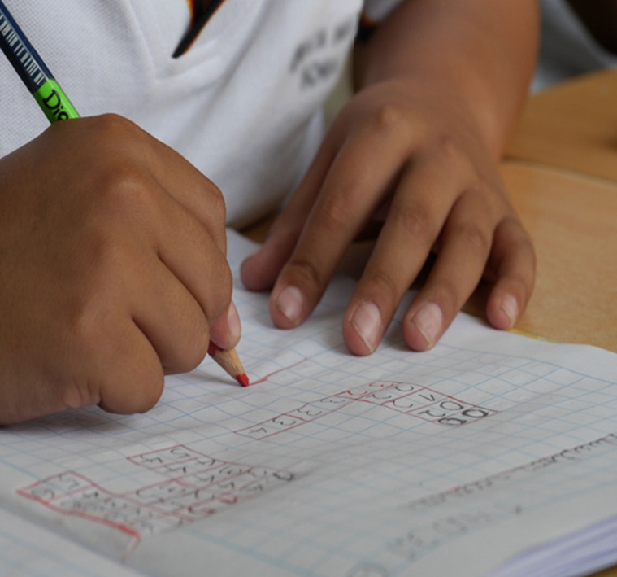

**Sample Rubrics for Self-Study Guides**

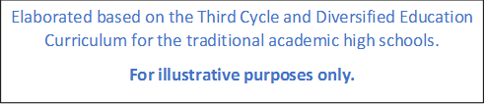

|  |  |  |  |
| --- | --- | --- | --- |
| **Eighth Grade. Unit 2 Scenario: Let the Good Times Roll!**  **Assessment Strategy L.2. Recognizes important information from audio texts (e.g., sports announcements, sports scores) provided if the message is delivered clearly.** | | | |
| **Indicators of Learning** | **Achievement level** | | |
| **Not yet achieved**  **1** | **In process**  **2** | **Achieved**  **3** |  |
| L.2.1 Restates orally the topic from audio texts about sports or sports announcements. | Learner cannot restate the topic from audio texts about sports or sports announcements correctly. | Learner can restate part of the topic from audio texts about sports or sports announcements with some difficulty and needs improvement. | Learner can restate the topic from audio texts about sports or sport announcements correctly and with no difficulty. |  |
| L.2.2 Labels illustrations in a conversation or story about sports or sports announcements. | Learner cannot label illustrations in a conversation or story about sports or sports announcements | Learner can label some of the illustrations in a conversations or story about sports or sports announcements with some difficulty and needs improvement. | Learner can label all illustrations in a conversation or story about sports or sports announcements correctly and with no difficulty. |  |
| L.2.3 Gets specific information to complete sentences with key words about sports | Learner cannot get any specific information to complete sentences with keywords about sports correctly. | Learner can get some specific information to complete sentences with keywords about sports with some difficulty and needs improvement. | Learner can get all the specific information to complete sentences with keywords about sports |  |
| L.2.4 Lists important information in a conversation or story about sports or sports announcements. | Learner cannot list information in a conversation or story about sports or sports announcements correctly. | Learner can list some important information in a conversation or story about sports or sports announcements with some difficulty and needs improvement. | Learner can list important information in a conversation or story about sports or sports announcements correctly and with no difficulty. |  |

Propuesta elaborada por: Marianella Granados Sirias, Alfredo Ortega Cordero Asesores Nacionales de Inglés. **Departamento de Tercer Ciclo y Educación Diversificada. Dirección de Desarrollo Curricular** con colaboración de Sandra Araya Acuña, Juan Solano Navarro. Asesores Regionales de Inglés.

|  |  |  |  |
| --- | --- | --- | --- |
| **Eighth Grade. Unit 2 Scenario: Let the Good Times Roll!**  **Assessment Strategy R.4. Recognizes most of what occurs in a well-structured short story and the story’s main characters.** | | | |
| **Indicators of Learning** | **Achievement level** | | |
| **Not yet achieved**  **1** | **In process**  **2** | **Achieved**  **3** |  |
| R4.1 identifies setting in a well-structured short story. | Learner cannot identify the setting in a well-structured short story correctly. | Learner can identify the setting in a well-structured short story with some difficulty and needs improvement. | Learner can identify the setting in a well-structured short story correctly and with no difficulty. |  |
| R4.2.1* names characters in a well-structured short story. | Learner cannot name characters in a well-structured short story. | Learner can name some characters in a well-structured short story with some difficulty and needs improvement. | Learner can describe all the characters in a well-structured short story correctly and with no difficulty. |  |
| R4.2.2* describes characters in a well-structured short story. | Learner cannot describe characters in a well-structured short story. | Learner can describe some characters in a well-structured short story with some difficulty and needs improvement. | Learner can describe characters in a well-structured short story correctly and with no difficulty. |  |
| R4.3 identifies main conflict/problem in a well-structured short story. | Learner cannot identify the main conflict/problem in a well-structured short story correctly. | Learner can identify the main conflict/problem in a well-structured short story with some difficulty and needs improvement. | Learner can identify the main conflict/problem in a well-structured short story correctly and with no difficulty. |  |
| R4.4.1* recounts some of the characters’ efforts in a well-structured short story. | Learner cannot recount the characters’ efforts in a well-structured short story correctly. | Learner can recount some of the characters’ efforts in a well-structured short story with some difficulty and needs improvement. | Learner can recount some of the characters’ efforts in a well-structured short story correctly and with no difficulty. |  |
| R4.4.2 * recounts some of the characters’ obstacles in a well-structured short story. | Learner cannot recount some of the obstacles in a well-structured short story correctly. | Learner can recount some of the obstacles in a well-structured short story with some difficulty and needs improvement. | Learner can recount some of the obstacles in a well-structured short story correctly and with no difficulty. |  |
| R4.5 summarizes the ending in a well-structured short story. | Learner cannot summarize the ending in a well-structured short story correctly. | Learner can summarize the ending in a well-structured short story with some difficulty and needs improvement. | Learner can summarize the ending in a well-structured short story correctly and with no difficulty. |  |

* Notice that indicators R.4.2.1 and R.4.2.2 are subdivided from R.4.2, same case with R.4.4.1 and R.4.4.2.

Propuesta elaborada por: Marianella Granados Sirias, Alfredo Ortega Cordero Asesores Nacionales de Inglés. **Departamento de Tercer Ciclo y Educación Diversificada. Dirección de Desarrollo Curricular** con colaboración de Sandra Araya Acuña, Juan Solano Navarro. Asesores Regionales de Inglés.

|  |  |  |  |
| --- | --- | --- | --- |
| **Eighth Grade. Unit 1 Scenario: My High School…Our place.**  **Assessment Strategy SI.1. Expresses common interests about school life.** | | | |
| **Indicators of Learning** | **Achievement level** | | |
| **Not yet achieved**  **1** | **In process**  **2** | **Achieved**  **3** |  |
| SI1.1 Selects the language and content to express common interests about school life. For example: My favorite is.., I don’t like … | Learner cannot select the language and content to express common interests about school life. For example: My favorite is.., I don’t like… correctly. | Learner can select part of the language and content to express common interests about school life. For example: My favorite is.., I don’t like… with some difficulty and needs improvement. | Learner can select all the language and content to express common interests about school life. For example: My favorite is.., I don’t like… correctly with no difficulty. |  |
| SI1. 2 Elaborates sentences to express common interests about school life. | Learner cannot elaborate sentences to express common interests about school life correctly. | Learner can elaborate some sentences to express common interests about school life with some difficulty and needs improvement. | Learner can elaborate sentences to express common interests about school life correctly with no difficulty. |  |
| SI1. 3 Expresses common interests about school life. | Learner cannot express common interests about school life correctly. | Learner can express some common interests about school life with some difficulty and needs improvement. | Learner can express common interests about school life correctly with no difficulty. |  |
| SI 1.4 Asks questions about others’ schedules. | Learner cannot ask questions about others´ schedules correctly. | Learner can ask some questions about others´ schedules with some difficulty and needs improvement. | Learner can ask questions about others´ schedules correctly with no difficulty. |  |
| SI 1.5 Answers questions about their own schedules. | Learner cannot answer questions about their own schedules correctly. | Learner can answer some questions about their own schedules with some difficulty and needs improvement. | Learner can answer questions about their own schedules correctly with no difficulty. |  |
| Maintains appropriate communication strategies while answering the questions stated (uses of facial expressions and gestures, asks for repetition, indicates lack of understanding, repeats words. | Learner cannot maintain communication most of the time. Hard for him/her to use the communication strategies to overcome difficulties correctly. | Learner can make correct use of some of the communication strategies to maintain communication going with some difficulty, but not all the time and inconsistently. Learner needs improvement. | Learner can make use of many communication strategies to maintain communication going, which helps to keep the flow of the conversation correctly with no difficulty. |  |
| Pronounces the target language in the answers provided correctly | Learner makes constant mistakes in pronunciation during his/her answers. (More than 4 mistakes) | Learner´s pronunciation is understandable at most times. Occasional mispronunciation; some consistent mistakes in his/her answers. (3-4 mistakes) | Learner has clear and smooth pronunciation in his/her answers at this level. Few sporadic deviations. (1-2 mistakes) |  |
| Stresses words and uses appropriate intonation in sentences or answers provided correctly. | Learner cannot stress individual words correctly and use appropriate intonation when forming sentences. | Learner can stress some individual words correctly and use appropriate intonation when answering with some difficulty and needs improvement. | Learner can constantly stress individual words correctly and use appropriate intonation when answering with no difficulty. |  |
| Speaks at a normal speed during the period of the interaction (question/answer task) | Learner carries out the task with hesitation that interferes with the message. Some long pauses to recall meaning. | Learner can carry out the task adequately with some hesitation that seldom interferes with the message. Few short pauses to recall meaning. | Learner can carry out the task with confidence. Very sporadic short pauses to recall meaning. |  |
| Uses the appropriate register and politeness conventions according to the given context and task. (Sociolinguistic Appropriateness) | Learner cannot use the appropriate register (formal or informal) for the task given. Expressions and word choice are contextually inappropriate in terms of manners, politeness and tactfulness. | Learner can partially use one register (formal or informal) without considering the task given. Expressions and word choice are sometimes contextually appropriate in terms of manners, politeness and tactfulness. Learner needs improvement. | Learner can fully use the appropriate register (formal or informal) at all times depending on the task and context given. Expressions and word choice are always contextually appropriate in terms of manners and politeness. |  |

**\* Notice that the assessment strategy, that includes indicators for asking and answering, must be separated subdividing the indicator. Besides, the indicators in green were constructed to measure overall achievement in aspects related to pronunciation, fluency and sociolinguistic appropriateness**. **They must be present in all instruments related to Spoken Interaction, Spoken production and Written as required.**

Propuesta elaborada por: Marianella Granados Sirias, Alfredo Ortega Cordero Asesores Nacionales de Inglés. **Departamento de Tercer Ciclo y Educación Diversificada. Dirección de Desarrollo Curricular** con colaboración de Sandra Araya Acuña, Juan Solano Navarro. Asesores Regionales de Inglés.

|  |  |  |  |
| --- | --- | --- | --- |
| **Eighth Grade. Unit 3 Scenario: Something to celebrate.**  **Assessment Strategy SI.2 asks and answers about holidays and festivals in Latin America and around the world. \*** | | | |
| **Indicators of Learning** | **Achievement level** | | |
| **Not yet achieved**  **1** | **In process**  **2** | **Achieved**  **3** |  |
| SI.2.2 Asks questions about local holidays, celebrations and festivals in Latin America and around the world | Learner cannot ask questions about local holidays, celebrations and festivals in Latin America and around the world correctly. | Learner can partially ask questions about local holidays, celebrations and festivals in Latin America and around the World with some difficulty and needs improvement. | Learner can fully ask questions about local holidays, celebrations and festivals in Latin America and around the world. |  |
| SI.2.4. Answers questions about local holidays, celebrations and festivals in Latin America and around the world. | Learner cannot answer questions about local holidays, celebrations and festivals in Latin America and around the world correctly. | Learner can partially answer questions about local holidays, celebrations and festivals in Latin America and around the world with some difficulty and needs improvement. | Learner can fully answer questions about local holidays, celebrations and festivals in Latin America and around the world correctly with no difficulty. |  |
| Maintains appropriate communication strategies while answering the questions stated (uses of facial expressions and gestures, asks for repetition, indicates lack of understanding, repeats words. | Learner cannot maintain communication most of the time. Hard for him/her to use the communication strategies to overcome difficulties correctly. | Learner can make correct use of some of the communication strategies to maintain communication going with some difficulty, but not all the time and inconsistently. Learner needs improvement. | Learner can make use of many communication strategies to maintain communication going, which helps to keep the flow of the conversation correctly with no difficulty. |  |
| Pronounces the target language in the answers provided correctly | Learner makes constant mistakes in pronunciation during his/her answers. (More than 4 mistakes) | Learner´s pronunciation is understandable at most times. Occasional mispronunciation; some consistent mistakes in his/her answers. (3-4 mistakes) | Learner has clear and smooth pronunciation in his/her answers at this level. Few sporadic deviations. (1-2 mistakes) |  |
| Stresses words and uses appropriate intonation in sentences or answers provided correctly. | Learner cannot stress individual words correctly and use appropriate intonation when forming sentences. | Learner can stress some individual words correctly and use appropriate intonation when answering with some difficulty and needs improvement. | Learner can constantly stress individual words correctly and use appropriate intonation when answering with no difficulty. |  |
| Speaks at a normal speed during the period of the interaction (question/answer task) | Learner carries out the task with hesitation that interferes with the message. Some long pauses to recall meaning. | Learner can carry out the task adequately with some hesitation that seldom interferes with the message. Few short pauses to recall meaning. | Learner can carry out the task with confidence. Very sporadic short pauses to recall meaning. |  |
| Uses the appropriate register and politeness conventions according to the given context and task. (Sociolinguistic Appropriateness) | Learner cannot use the appropriate register (formal or informal) for the task given. Expressions and word choice are contextually inappropriate in terms of manners, politeness and tactfulness. | Learner can partially use one register (formal or informal) without considering the task given. Expressions and word choice are sometimes contextually appropriate in terms of manners, politeness and tactfulness. Learner needs improvement. | Learner can fully use the appropriate register (formal or informal) at all times depending on the task and context given. Expressions and word choice are always contextually appropriate in terms of manners and politeness. |  |

**\* Notice that the assessment strategy, that includes indicators for asking and answering, must be separated subdividing the indicator. Besides, the indicators in green were constructed to measure overall achievement in aspects related to pronunciation, fluency and sociolinguistic appropriateness**. **They must be present in all instruments related to Spoken Interaction, Spoken production and Written Production as required.**

Propuesta elaborada por: Marianella Granados Sirias, Alfredo Ortega Cordero Asesores Nacionales de Inglés. **Departamento de Tercer Ciclo y Educación Diversificada. Dirección de Desarrollo Curricular** con colaboración de Sandra Araya Acuña, Juan Solano Navarro. Asesores Regionales de Inglés.

|  |  |  |  |
| --- | --- | --- | --- |
| **Eighth Grade. Unit 3 Scenario: Something to celebrate.**  **Assessment Strategy SP.2 describes what he/she did on his /her last holiday.** | | | |
| **Indicators of Learning** | **Achievement level** | | |
| **Not yet achieved**  **1** | **In process**  **2** | **Achieved**  **3** |
| SP2.1 Notes down the appropriate information to describe the last holiday. | Learner cannot note down the appropriate information to describe the last holiday. | Learner can partially note down the appropriate information to describe the last holiday with some difficulty and needs improvement. | Learner can fully note down the appropriate information to describe the last holiday correctly with no difficulty. |
| SP2.2 Organizes the information and resources to describe the last holiday. | Learner cannot organize the information and resources to describe the last holiday  correctly. | Learner can partially organize the information and resources to describe the last holiday with some difficulty and needs improvement. | Learner can fully organize the information and resources to describe the last holiday correctly with no difficulty. |
| SP2.3 Makes sentences about the last holiday. | Learner cannot make sentences about the last holiday correctly. | Learner can partially make sentences about the last holiday with some difficulty and needs improvement. | Learner can fully make sentences about the last holiday correctly with no difficulty. |
| SP2.4 Describes the last holiday using sequential past time. | Learner cannot describe the last holiday using sequential past time: first, then, after that, finally correctly. | Learner can partially describe the last holiday, but does not use sequential past time: first, then, after that, finally with some difficulty and needs improvement. | Learner can fully describe the last holiday using sequential: past time first, then, after that, finally correctly with no difficulty. |
| Maintains appropriate  communication strategies to describe holidays (uses of facial expressions and gestures,   asks for repetition, indicates lack of understanding, repeats words). | Learner cannot maintain communication most of the time. Hard for him/her to use the communication strategies to overcome difficulties correctly. | Learner can make correct use of some of the communication strategies to maintain communication going with some difficulty, but not all the time and inconsistently. Learner needs improvement. | Learner can make use of many communication strategies to maintain communication going, which helps to keep the flow of the conversation correctly with no difficulty. |
| Pronounces the target language  about holidays correctly. | Learner makes constant mistakes in pronunciation. (More than 4 mistakes) | Learner pronunciation is understandable at most times. Occasional mispronunciation; some consistent mistakes. (3-4 mistakes) | Learner has clear and smooth pronunciation at this level. Few sporadic deviations. (1-2 mistakes) |
| SP.2.4.3 Stresses words and use appropriate intonation in sentences correctly. | Learner cannot stress individual words correctly and does not use appropriate intonation when making sentences. | Learner can stress individual words correctly and use appropriate intonation when making sentences with some difficulty and needs improvement. | Learner can constantly stress individual words correctly and use appropriate intonation when making sentences with no difficulty. |
| SP.2.4.4 Speaks at a normal speed during the production task | Learner carries out the task with hesitation that interferes with the message. Some long pauses to recall meaning. | Learner can carry out the task adequately with some hesitation that seldom interferes with the message. Few short pauses to recall meaning. | Learner can carry out the task with confidence. Very sporadic short pauses to recall meaning. |
| SP.2.4.5 Uses the appropriate register and politeness conventions according to the given context and task. (Sociolinguistic Appropriateness) | Learner cannot use the appropriate register (formal or informal) for the task given. Expressions and word choice are contextually inappropriate in terms of manners, politeness and tactfulness. | Learner can partially use one register (formal or informal) without considering the context given. Expressions and word choice are sometimes contextually appropriate in terms of manners, politeness and tactfulness. Learner needs improvement. | Learner can fully use the appropriate register (formal or informal) at all times depending on the task and context given. Expressions and word choice are always contextually appropriate in terms of manners and politeness. |

**\* The indicators in green were constructed to measure overall achievement in aspects related to pronunciation, fluency and sociolinguistic appropriateness**. **They must be present in all instruments related to Spoken Interaction, Spoken production and Written Production** as required.

Propuesta elaborada por: Marianella Granados Sirias, Alfredo Ortega Cordero Asesores Nacionales de Inglés. **Departamento de Tercer Ciclo y Educación Diversificada. Dirección de Desarrollo Curricular** con colaboración de Sandra Araya Acuña, Juan Solano Navarro. Asesores Regionales de Inglés.

|  |  |  |  |
| --- | --- | --- | --- |
| **Eighth Grade Unit 1 Scenario: My High School…Our place**  **Assessment Strategy: W.2. Writes an explanation of what they do every day at school, with the help of illustrations.** | | | |
| **Indicators of Learning** | **Achievement level** | | |
| **Not yet achieved**  **1** | **In process**  **2** | **Achieved**  **3** |
| **W2.1** Drafts an explanation with illustrations about activities in a typical day at school, and a conclusion | Learner cannot draft an explanation with illustrations about a typical day at school, and a conclusion correctly. | Learner can partially draft an explanation with illustrations about a typical day at school, and a conclusion with some difficulty and needs improvement. | Learner can fully draft an explanation with illustrations about a typical day at school, and a conclusion correctly and with no difficulty. |
| **W2.2** Revises the explanation about a typical day at school. | Learner cannot revise the explanation about a typical day at school correctly. | Learner can partially revise the explanation about a typical day at school with some difficulty and needs improvement. | Learner can fully revise the explanation about a typical day at school correctly and with no difficulty. |
| **W2.2.1 * Checks** written sentences to look for mistakes related to subject-verb agreement, capitalization, spelling, and basic punctuation). | Learner cannot check the written sentences presenting constant subject verb agreement, capitalization, spelling, and punctuation mistakes. | Learner can partially check the written sentences and some subject verb agreement, capitalization, spelling, and punctuation mistakes. | Learner can fully check the written sentences avoiding subject verb agreement, capitalization, spelling, and punctuation mistakes. |
| W2.2.2*Arranges Linking words, groups of words, sentences, paragraphs, and texts in a well-organized and logical manner. (Coherence and Cohesion) | Learner‘s production cannot show sense of coherence & cohesion. No sense in the organization of its content and use of discourse markers. | Learners' production can partially show a sense through the organization of its content and use of discourse markers. | Learner's production can fully show reasonable sense through the organization of its content and use of discourse markers. |
| W2.2.3* Uses the appropriate register and politeness conventions according to the given context. (Sociolinguistic Appropriateness | Learner cannot use the appropriate register (formal or informal) for the task given. Expressions and word choice are contextually inappropriate in terms of manners, politeness and tactfulness. | Learner can partially use one register (formal or informal) without considering the context given. Expressions and word choice are sometimes contextually appropriate in terms of manners, politeness and tactfulness. Learner needs improvement. | Learner can fully use the appropriate register (formal or informal) at all times depending on the task and context given. Expressions and word choice are always contextually appropriate in terms of manners and politeness. |
| **W2.3** Edits the explanation by correcting the mistakes before publishing it. | Learner cannot edit the explanation by correcting the mistakes before publishing it correctly. | Learner can partially edit the explanation by correcting the mistakes before publishing it with some difficulty and needs improvement. | Learner can fully edit the explanation by correcting the mistakes before publishing it correctly and with no difficulty. |
| Links words, groups of words, sentences, paragraphs, and texts in a well-organized and logical manner. (Coherence and Cohesion) | Learner‘s production cannot show sense of coherence & cohesion. No sense in the organization of its content and use of discourse markers. | Learners' production can partially show a limited sense through the organization of its content and use of discourse markers. | Learner's production can fully show reasonable sense through the organization of its content and use of discourse markers. |
| Uses the appropriate register and politeness conventions according to the given context. (Sociolinguistic Appropriateness | Learner cannot use the appropriate register (formal or informal) for the task given. Expressions and word choice are contextually inappropriate in terms of manners, politeness and tactfulness. | Learner can partially use one register (formal or informal) without considering the context given. Expressions and word choice are sometimes contextually appropriate in terms of manners, politeness and tactfulness. Learner needs improvement. | Learner can fully use the appropriate register (formal or informal) at all times depending on the task and context given. Expressions and word choice are always contextually appropriate in terms of manners and politeness. |

* Notice that Indicator W2.2.1 comes from Indicator W2.2, and that W2.2.1, W2.2.2, and W2.2.3 are subdivided from Indicator W2.2. The indicators in green were constructed to measure overall achievement in aspects related to pronunciation, fluency and sociolinguistic appropriateness. They must be present in all instruments related to Spoken Interaction, Spoken production and Written Production as required.

Propuesta elaborada por: Marianella Granados Sirias, Alfredo Ortega Cordero Asesores Nacionales de Inglés. Departamento de Tercer Ciclo y Educación Diversificada. Dirección de Desarrollo Curricular con colaboración de Sandra Araya Acuña, Juan Solano Navarro. Asesores Regionales de Inglés.

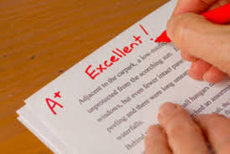

Sample Rubrics and Performance Scale for Summative Assessment Instruments and the Assessment Promotion Strategy

|  |  |  |  |  |  |
| --- | --- | --- | --- | --- | --- |
| **Analytic Rubric**  High School:___________________                                 Score:_____________  Summative instrument                                                                  Total Points:  ________  Allotted Time: ____________minutes       Gotten points: _______  Level: Eighth Grade Percentage: __________%  Teacher: __________________________          Obtained Percentage: ____________  Date: _____________________________  Student`s name:____________________________________                         Group:___________ | | | | | |
| **Scenario** | Let the Good Times Roll! | | | | |
| **Assessment Strategy** | R.4 Recognizes most of what occurs in a well-structured short story and the story´s main characters. | | | | |
| **Task** | Today is your birthday. Your best friend gave you a book with different short stories as a present. From the book, read the short story “A day I’ll never forget” and work on the following guide to make a summary for your mother.   * + - 1. Identify the setting of the story.       2. Name all characters in the story.       3. Describe each character of the story.       4. Identify the main conflict/problem of the story.       5. Recount some of the characters´ efforts.       6. Recount some of the characters´ obstacles.       7. Summarize the ending of the story. | | | | |
| **Indicator of Learning** | | **N/A**  **0** | **Achievement level** | | |
| **Not yet achieved**  **1** | **In process**  **2** | **Achieved**  **3** |
| R4.1 identifies setting in a well-structured short story. | |  | Learner cannot identify the setting in a well-structured short story correctly. | Learner can partially identify the setting in a well-structured short story with some difficulty and needs improvement. | Learner can fully identify the setting in a well-structured short story correctly and with no difficulty. |
| R4.2 names characters in a well-structured short story. | |  | Learner cannot name characters in a well-structured short story. | Learner can name some characters in a well-structured short story with some difficulty and needs improvement. | Learner can name all the characters in a well-structured short story correctly and with no difficulty. |
| R4.2 describes characters in a well-structured short story. | |  | Learner cannot describe characters in a well-structured short story. | Learner can partially describe some characters in a well-structured short story with some difficulty and needs improvement. | Learner can fully describe all the characters in a well-structured short story correctly and with no difficulty. |
| R4.3 identifies main conflict/problem in a well-structured short story. | |  | Learner cannot identify the main conflict/problem in a well-structured short story correctly. | Learner can partially identify the main conflict/problem in a well-structured short story with some difficulty and needs improvement. | Learner can fully identify the main conflict/problem in a well-structured short story correctly and with no difficulty. |
| R4.4 recounts some of the characters’ efforts in a well-structured short story. | |  | Learner cannot recount some of the characters’ efforts in a well-structured short story correctly. | Learner can partially recount some of the characters’ efforts in a well-structured short story with some difficulty and needs improvement. | Learner can fully recount all of the characters’ efforts in a well-structured short story correctly and with no difficulty. |
| R4.4 recounts some of the characters’ obstacles in a well-structured short story. | |  | Learner cannot recount some of the obstacles in a well-structured short story correctly. | Learner can partially recount some of the obstacles in a well-structured short story with some difficulty and needs improvement. | Learner can fully recount all of the obstacles in a well-structured short story correctly and with no difficulty. |
| R4.5 summarizes the ending in a well-structured short story. | |  | Learner cannot summarize the ending in a well-structured short story correctly. | Learner can partially summarize the ending in a well-structured short story with some difficulty and needs improvement. | Learner can fully summarize the ending in a well-structured short story correctly and with no difficulty. |

Propuesta elaborada por: Sandra Araya Acuña, Juan Solano Navarro. Asesores Regionales de Inglés y validada por Marianella Granados Sirias, Alfredo Ortega Cordero Asesores Nacionales de Inglés. Departamento de Tercer Ciclo y Educación Diversificada. Dirección de Desarrollo Curricular.

|  |  |  |  |  |  |  |  |
| --- | --- | --- | --- | --- | --- | --- | --- |
| **Oral Performance Scale-Sample (Oral Production)**  **Dos Cercas High School                                        Score:_____________**  **Summative instrument                                                                  Total Points:  ________**  **Allotted Time: ____________minutes       Gotten points: _______**  **Level: Eighth Grade Percentage: __________%**  **Teacher: __________________________          Obtained Percentage: ____________**  **Date: _____________________________**  **Student`s name:____________________________________                         Group:___________** | | | | | | | |
| **Scenario:** | | **Something to Celebrate!** | | | | | |
| **Assessment Strategy** | | **SI.2.** Asks and answers about holidays and festivals in Costa Rica, Latin America and around the World. | | | | | |
| **Description of linguistic task** | | **Information exchange (2 minutes)**  You are participating in an international school summer camp. You were asked to talk about favorite holidays or celebrations around the world. Choose one and talk about when and where it is celebrated, special food, activities. Use pictures to talk about it and ask questions to the teacher or classmates. Answer a couple of questions from your teacher or classmates. | | | | | |
| **Indicators\*** | **Points per indicator** | |  | | | | |
| **N/A**  **0** | **1** | **2** | **3** | **4** |
| **Asks questions about holidays and festivals in Costa Rica, Latin America and around the World.** | 3 | |  | Asks questions about holidays and festivals in Costa Rica, Latin America and around the World with a lot of difficulty. The student fails to ask for most of the information (He/she cannot control memorized language structures (question patterns), so it is hard to be understood. | Asks questions about holidays and festivals in Costa Rica, Latin America and around the World appropriately sometimes. The student asks information about some of the elements.  He/she can partially control memorized language structures                (question patterns), to be somehow understood. | Asks questions about holidays and festivals in Costa Rica, Latin America and around the World appropriately and with ease. The student gets to ask for information about all the elements. He/she can consistently control basic language structures (question patterns) |  |
| **Answers questions about holidays and festivals in Costa Rica, Latin America and around the World.** | 4 | |  | Answers were incomplete He/she hardly answers questions about holidays and festivals in Costa Rica, Latin America and around the World appropriately when asked.  He/she cannot identify the question word and helping verb to provide an answer with control of memorized language structures (sentence patterns), so it is hard to be understood. | Answers were partially accomplished. He/she sometimes answers questions about holidays and festivals in Costa Rica, Latin America and around the World appropriately when asked. He/she can partially identify the question word and helping verb to provide an answer with control of memorized language structures (sentence patterns) to be somehow understood. | Answers were accomplished. Most of the time, he/she answers questions about holidays and festivals in Costa Rica, Latin America and around the World appropriately when asked.  He/she can identify question words, helping verb and basic language structures (sentence patterns) at most times. | Answers were successfully accomplished. He/she, at all times, answers questions about holidays and festivals in Costa Rica, Latin America and around the World appropriately when asked.  He/she can consistently identify question words, helping verb and basic language structures (sentence patterns) |
| **Gives information about holidays and festivals in Costa Rica, Latin America and around the World.** | 3 | |  | The task was incomplete He/she hardly gives information about holidays and festivals in Costa Rica, Latin America and around the World. He/she cannot control memorized language structures (sentence patterns), so it is hard to be understood | The task was partially accomplished. He/she somewhat gives information about holidays and festivals in Costa Rica, Latin America and around the World by either talking about the holiday or festival name or date of celebration. He/she can partially control memorized language structures  (sentence pattern), to be somehow understood | The task was successfully accomplished. He/she gives information about holidays and festivals in Costa Rica, Latin America and around the World by talking about when and where they are celebrated, special food, activities.  He/she can consistently control basic language structures (sentence patterns) |  |
| **\*Uses appropriate**  **communication**  **strategies (uses of facial expressions**  **and gestures, asks for repetition, indicates lack of understanding,**  **repeats words).** | 3 | |  | Fails in maintaining communication most of the time. Hard for him/her to use the communication strategies to overcome difficulties. | Makes use of some of the communication strategies to maintain communication going, but not all the time and inconsistently. | Makes use of many communication strategies to maintain communication going, which helps to keep the flow of the conversation | . |
| **\*Pronounces the target language correctly** | 3 | |  | Difficulty at understanding. Constant mistakes in pronunciation  (More than 4 mistakes) | Understandable at most times. Occasional mispronunciation; some consistent mistakes.  (3-4 mistakes) | Clear and smooth pronunciation at this level. Few sporadic deviations.  (1-2 mistakes) |  |
| **\*Stresses words and sentences correctly** | 2 | |  | Sometimes  stresses individual words correctly and uses appropriate intonation when forming sentences | Constantly stresses individual words correctly and uses appropriate intonation when forming sentences |  |  |
| **\*Speaks at a**  **normal speed** | 3 | |  | Carried out with hesitation that sometimes interferes with the message. Some long pauses to recall meaning. | Carried out adequately with some hesitation that seldom interferes with the message. Few short pauses to recall meaning. | Carried out with confidence. Sporadic short pauses to recall meaning. |  |
| **Total:** | 23 | |  |  |  |  |  |
| **Comments:** | | | | | | | |

**\*The indicators related to pronunciation, fluency and sociolinguistic appropriateness were constructed to measure overall achievement**. **They must be present in all instruments related to Spoken Interaction and Spoken production as required.**

Propuesta elaborada por: Marianella Granados Sirias y Alfredo Ortega Cordero. Asesores Nacionales de Inglés. **Departamento de Tercer Ciclo y Educación Diversificada. Dirección de Desarrollo Curricular, 2021.**

**References**

Curriculum Services Canada, A Guide to Reflective Practice for Core French Teachers, The Action-Oriented Approach. Module 3. Ministry of Education and the Government of Canada through the Department of Canadian Heritage.

Common European Framework of Reference for Languages: Learning, Teaching, Assessment (2003). Cambridge, U.K.: Press Syndicate of the University of Cambridge.

Common European Framework of Reference for Languages: Learning, Teaching, Assessment (2018). Cambridge, U.K.: Press Syndicate of the University of Cambridge.

Frade, L. (2009) Desarrollo de Competencias en Educación. Inteligencia Educativa. 2 edición (295-402)

Ministerio de Educación Pública (2021). Lineamientos técnicos para el proceso de evaluación, curso lectivo 2021. San José, Costa Rica: MEP.

Ministerio de Educación Pública (2021). Mediación Pedagógica para la Educación Combinada, curso lectivo 2021. San José, Costa Rica: MEP.

Ministerio de Educación Pública (2016). Programa de Estudio de Inglés Tercer Ciclo y Educación Diversificada Académico. San José, Costa Rica: MEP.

Ministerio de Educación Pública (2017). Programa de Estudio de Inglés Plan de Estudios Liceo Bilingüe Secciones Bilingües español –Inglés Tercer Ciclo. San José, Costa Rica: MEP.

Ministerio de Educación Pública (2020). Programa de Estudio de Inglés Plan de Estudios Liceo Bilingüe Secciones Bilingües español –Inglés Educación Diversificada. San José, Costa Rica: MEP.

https://www.orientacionandujar.es/2016/11/06/taxonomia-robert-marzano-verbos-recomendados-indicadores-niveles-cognitivos/